**INSILICO SYSTEMS BIOLOGY PRACTICALS**

**EXPERIMENT – 11**

**Aim** – To explore Database RHEA

**Theory-**

Rhea is an expert curated resource of biochemical reactions designed for the annotation of enzymes and genome-scale metabolic networks and models. Rhea uses the [ChEBI](http://www.ebi.ac.uk/chebi%22%20/t%20%22_blank) (Chemical Entities of Biological Interest) ontology of small molecules to precisely describe reactions of participants and their chemical structures. All reactions are balanced for mass and charge and are linked to source literature, metabolic resources and other functional vocabularies such as the enzyme classification of the NC-IUBMB.

An important goal of the Rhea project is to link the chemical information from ChEBI to that in resources describing enzymatic reactions, such as IntEnz (Integrated relational Enzyme database) that contains data on enzymes organized by EC numbers. ChEBI provides information on chemical compounds for the creation of chemical reactions in Rhea. The resulting Rhea reactions are used in IntEnz to describe the enzymes catalyzing the reactions. ENZYME is generated from IntEnz data and currently uses the textual representation reactions also used by the IUBMB EC list.

Rhea includes 4321 master reactions (each associated with three directional reactions) that involve 3788 distinct ChEBI chemical entities. Among them, 251 are transport reactions. In the corresponding IntEnz database (release 71) 3145 of the 4596 enzyme entries (EC numbers) have their reactions described in Rhea. This corresponds to a total of 3658 distinct Rhea reactions (as there may be a many-to-many relationship between reactions and enzymes).

All data in Rhea is freely accessible and available for anyone to use.

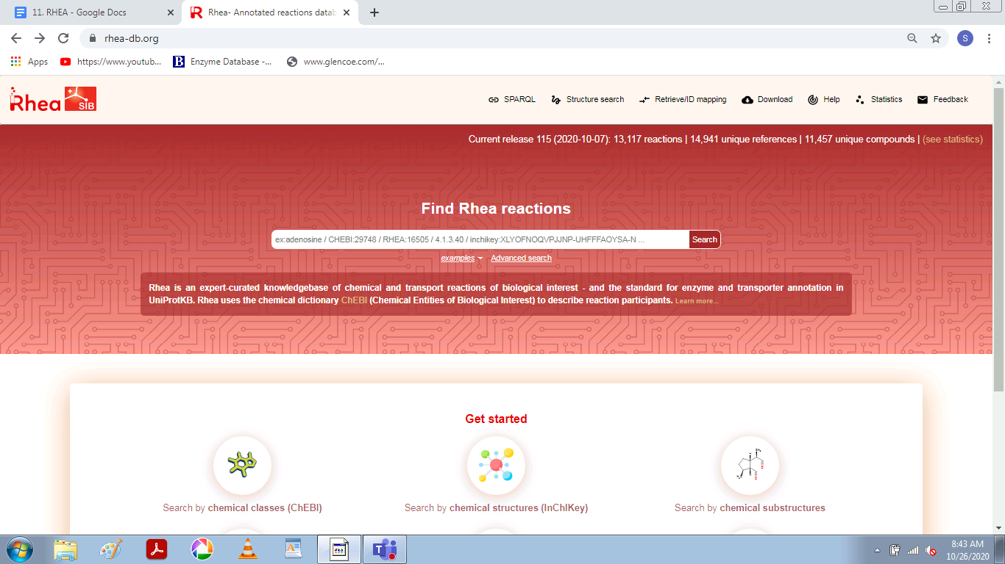

**PROCEDURE**

1. Enter the URL - <https://www.rhea-db.org/home>
2. In the search box, look for E. coli or any desired organism, reaction, metabolite etc.

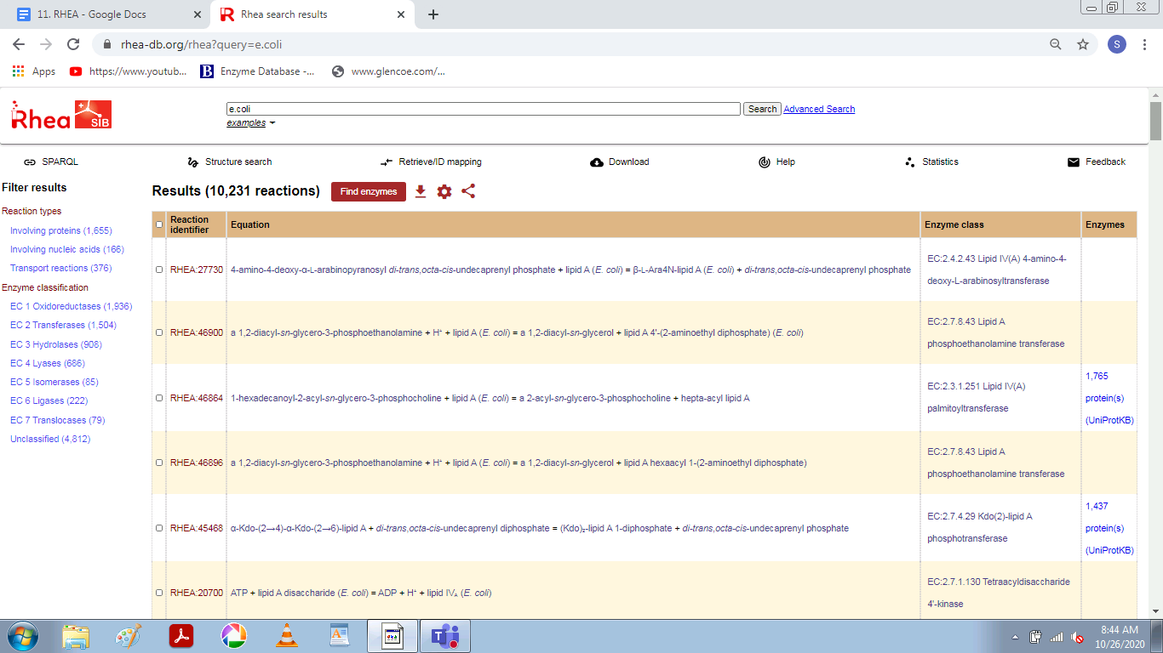

1. From this list, choose the respective hit in which you are interested and click on its accession id.

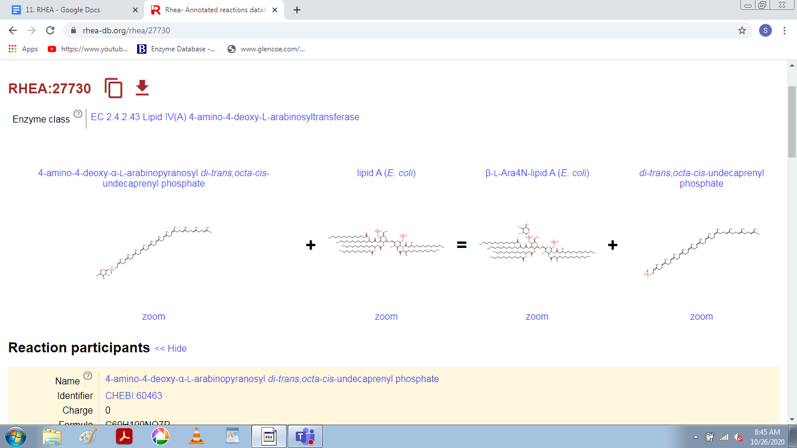

1. Other information like reaction relation and links to other resources can also be obtained.

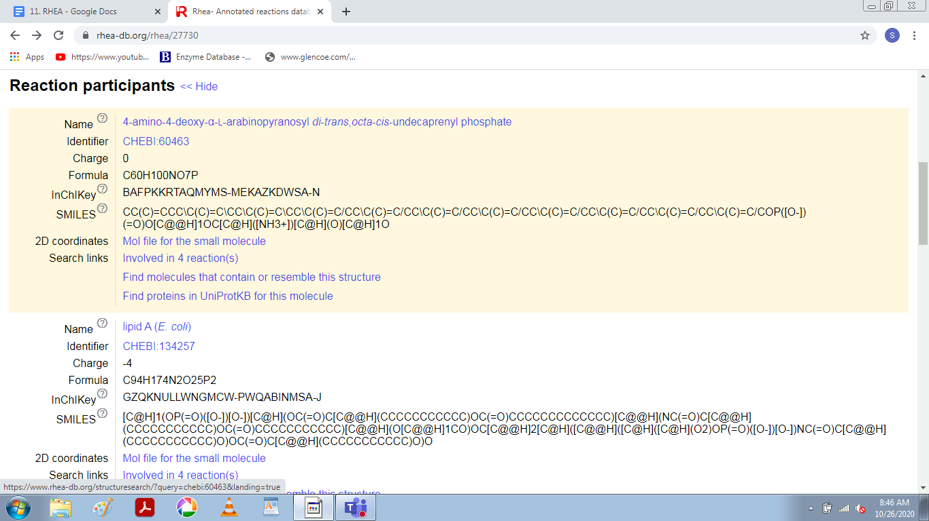

**INSILICO SYSTEMS BIOLOGY PRACTICALS**

**EXPERIMENT -12**

**Aim:** To explore ModelSEED Database.

**URL:** <http://modelseed.org/>

**Theory:** ModelSEED is a resource for the reconstruction, exploration, comparison, and analysis of metabolic models. The **ModelSEED** resource is based upon work supported by the U.S. Department of Energy, Office of Biological and Environmental Research; under contract DE-AC02-06CH11357 and by the National Science Foundation grant number MCB-1153357.

The **PlantSEED** resource was created with support by the National Science Foundation Grant IOS-1025398, by an endowment from the C. V. Griffin Sr. Foundation, and by the Office of Science, Office of Biological and Environmental Research, of the US Department of Energy (DOE) under Contract DE-ACO2-06CH11357, as part of the DOE Systems Biology Knowledgebase.

The National Science Foundation Grant IOS-1444202 has provided support for both the improvement of the PlantSEED resource and the production of new modeling tools within ModelSEED to be able to annotate plant genomes using the PlantSEED platform and develop plant metabolism models. This grant also supports the implementation of four PlantSEED metabolic modeling workshops to train faculty, post-doctoral fellows and graduate students of American universities (with an emphasis on recruitment of faculty from minority serving institutions) in the use of these novel computational tools.

Much of the data included in the ModelSEED is dervied from numerous published manuscripts and databases.

PROCEDURE –

1. Create an account on - rast.nmpdr.org , which takes approx 24 hrs to activate the modelseed account.

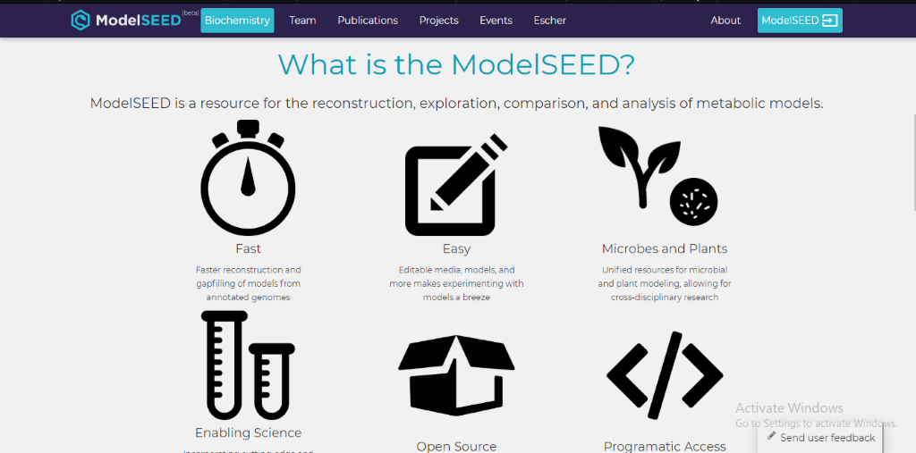

*Figure 1: Homepage of ModelSEED*

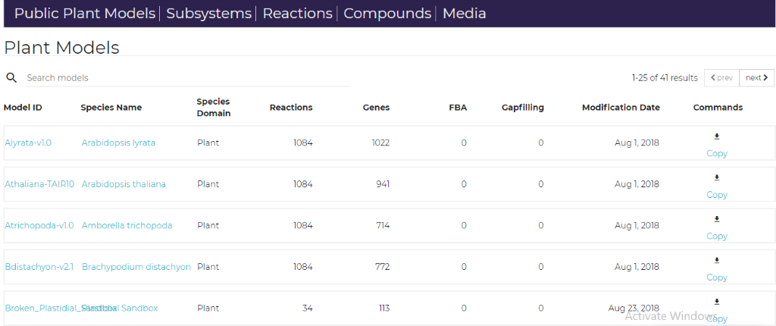

*Figure 2: Menu Bar on top with different components.*

1. Clicking on first model, i.e.  Alyrata-v1.0, in the given list, the following page shows up.

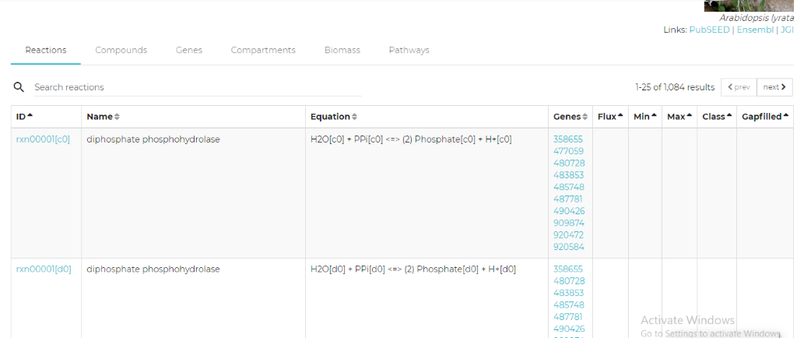

*Figure 3: Showing the reactions invovled in Arabidopsis lyrata plant*

1. Clicking on compounds tab from menu bar, opens up the below page:

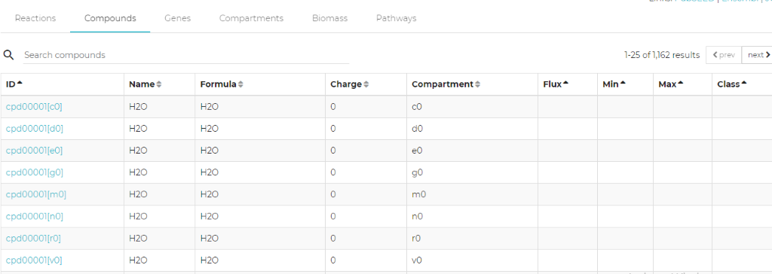

*Figure 4: List of Compounds present in the reactions and model*

1. Clicking on Genes tab from menu bar, opens up the below page:

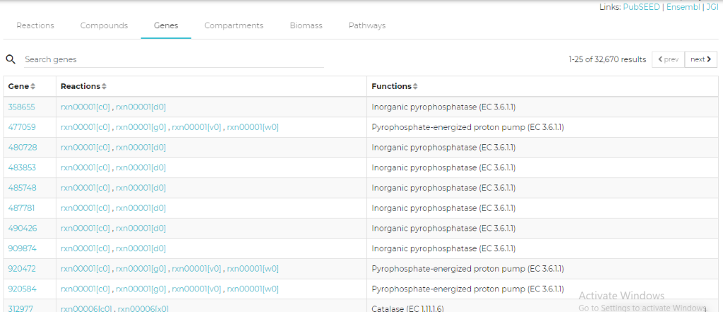

*Figure 5: Genes*

1. Clicking on Compartments tab from menu bar, opens up the below page:

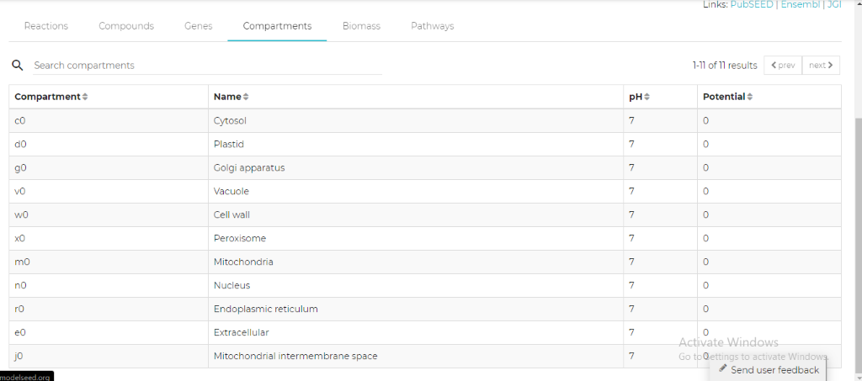

*Figure 6: Compartments of the plant cell*

1. The mass of each product is provided in the Biomass tab of the result and the Pathways in which these compounds involved are given in the pathways tab of the page.

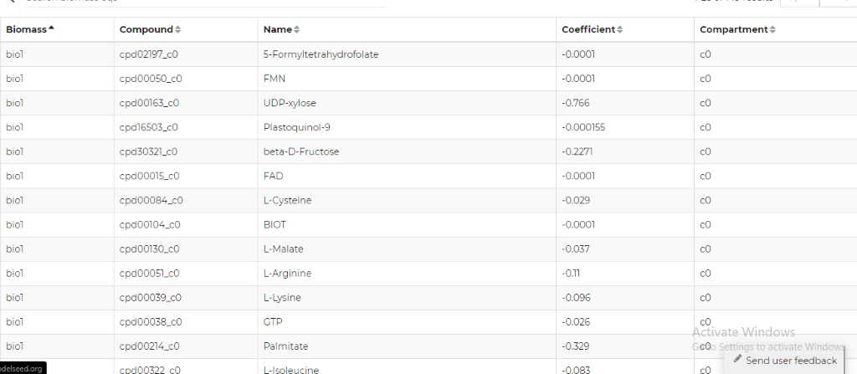

*Figure 7: BIOMASS*

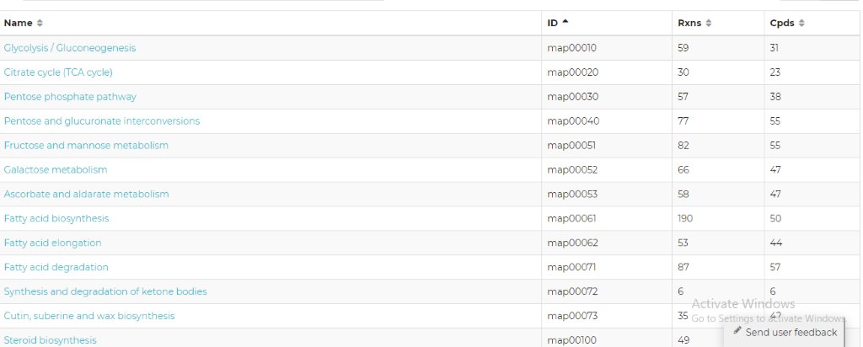

*Figure 8: Pathways*

* The user can build its own model in ModelSEED by adding the FASTA sequence of the plants or microbes.



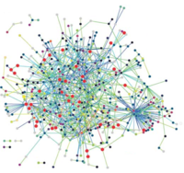 **Insilico System Biology Practical**

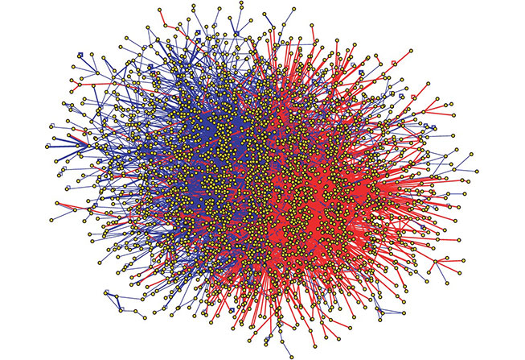

**Submitted by: Subhadeep Basu, Enrollment no: A9500320010**

**First year M.Sc. Bioinformatics Amity University Noida**

**Batch 2020-2022**

**EXPERIMENT - 13**

**Aim-** To explore an E. coli GEM, human GEM and yeast GEM using Metabolic ATLAS

**Tools Used**- **METABOLIC ATLAS**

**URL-** <https://www.metabolicatlas.org/>

**Theory-** Metabolic Atlas allows users to visualize the content of the integrated [Genome-scale metabolic models (GEMs)](https://metabolicatlas.org/documentation#Integrated-models) by using the [GEM browser](https://metabolicatlas.org/documentation#GEM-Browser) tool, and enables navigation of the metabolic network maps via the [Map viewer](https://metabolicatlas.org/documentation#Map-Viewer) tool. These two tools are available upon selecting one of the integrated models. The selected model is indicated to the right of the Metabolic Atlas logo in the top navigation bar. Leaving the Explore section (or the GEM Browser / Map Viewer tools) will unselect the model, and remove its name from the navigation bar.

To browse our integrated GEMs, visit the [GEM Repository](https://metabolicatlas.org/gems/repository) page.

The GEM Browser and the Map Viewer are closely connected, and users can navigate between the two tools using the buttons in the top navigation bar.

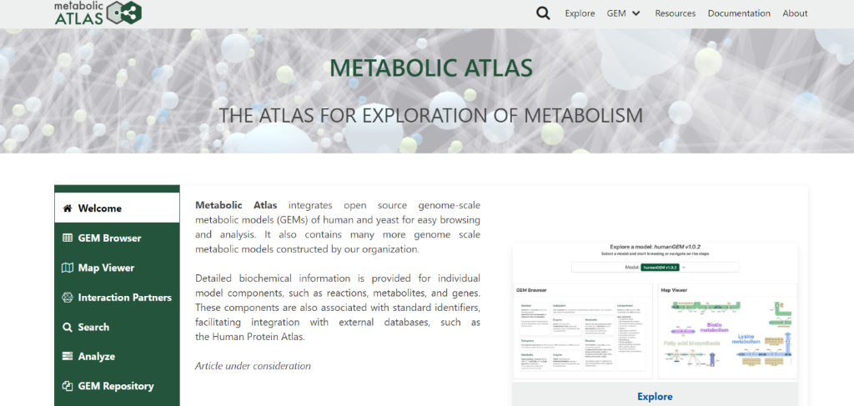

**Exploring the browser-**

1. Open GEM repository

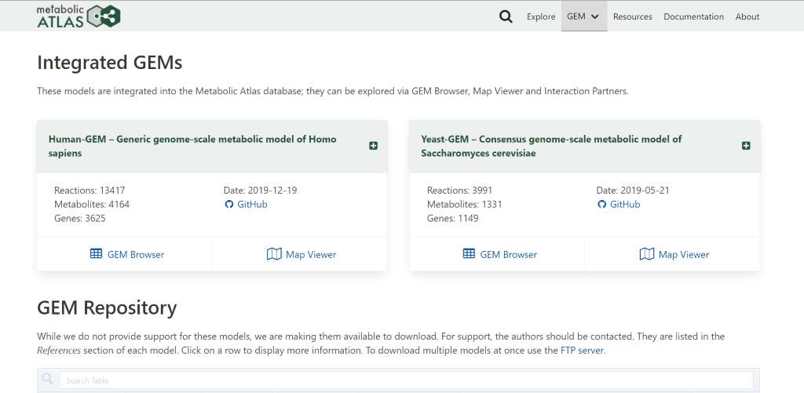

Here you can see for human GEM there are two parts namely:

* GEM browser
* Map viewer

GEM BROWSER

The *GEM Browser* is a set of dedicated pages for different components of the model; reactions, metabolites, genes, subsystems, and compartments.

MAP VIEWER

The *Map Viewer* is a separate and independent interface, accessible after an integrated model has been selected. It includes a 2D viewer to vizualize metabolic maps in SVG format, and a 3D viewer to explore the metabolic network in 3 dimensions. Users can easly toggle between the *GEM Browser* and *Map Viewer* using the buttons in the top navigation bar.

To switch between 2D maps and 3D network, use the "Switch to 2D" or "Switch to 3D" button in the top left of the map, respectively. This button is disabled for a model without 2D maps, or when the corresponding 2D version of a 3D network is not available. The two left sidebar buttons are used to select which compartment or subsystem will be shown in the viewer.

1. Now open human GEM browser

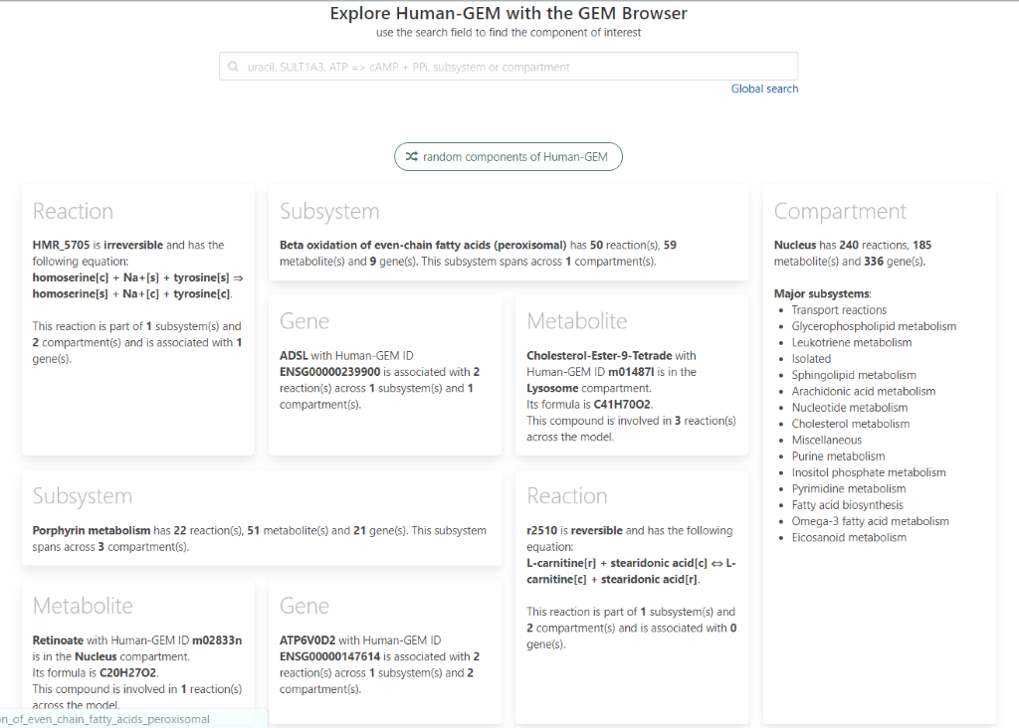

In the above page you can see the following:

**GEM Browser**

**Reaction page**

This page shows information about the current selected reaction. If available, a list of references (PMIDs) is also shown in the Reference table below.

On the right of the page, a list of maps/networks where this reaction can be vizualize is displayed. Clicking on a map name will redirect the user to the *Map Viewer* tool; to return back to the *GEM Browser*, click the *GEM Browser* button in the top navigation bar.

**Metabolite page**

The Metabolite page shows information on the current selected metabolite. Metabolites in GEMs are often differentiated according to their cell compartment localization (e.g., endoplasmic reticulum). For this reason, one metabolic species, e.g. cholesterol, may correspond to several different metabolite entries in a GEM, such as cholesterol[c], cholesterol[m], etc. (the suffix indicates the compartment in which the metabolite is localized).

The top table contains basic information extracted from the GEM. If provided, several additional identifiers from external databases will be shown in the External IDs table below.

On the right side of the page, users can access the [Interaction Partners](https://metabolicatlas.org/documentation#Interaction-Partners) tool for the metabolite.

**Reactions table**

Lists all the reactions involving the current metabolite as a reactant or a product. The current metabolite is denoted with a black text color in the reaction equations. Since metabolites are specific to a cell compartment, only reactions involving the metabolite in its specific compartment are displayed. To remove this restriction and display additional reactions involving the metabolite in any compartment, click the *Expand to all compartments* button.

Note that the number of reactions is limited to 200; to retrieve all the reactions we invite users to use the [API](https://metabolicatlas.org/documentation#API).

**Gene page**

Shows information about the current selected gene. The top table contains basic information extracted from the GEM. If provided, several additional identifiers from external databases will be shown in the external IDs table.

On the right side of the page, users can access the [Interaction Partners](https://metabolicatlas.org/documentation#Interaction-Partners) tool for this gene.

**Reactions table**

Lists all the reactions catalyzed by the enzyme encoded by the current gene.

Note that the number of reactions is limited to 200; to retrieve all the reactions we invite users to use the [API](https://metabolicatlas.org/documentation#API).

**Subsystem page**

This page shows information on the current selected metabolic subsystem. Subsystems correspond to a set of reactions that share a similar metabolic function. Unlike a metabolic pathway, the reactions comprising a subsystem are not necessarily linked into a completely connected network.

A list of metabolites and genes contained within the current subsystem are shown in the table, but are restricted to a maximum of 1000 for each category. Use the [API](https://metabolicatlas.org/documentation#API) to retrieve the complete set of metabolites and genes for the selected subsystem.

**Reactions table**

Shows all the reactions that belong to the current subsystem. Note that in some GEMs, a given reaction can be associated with multiple subsystems. The number of reactions shown is limited to 1000; to retrieve all associated reactions we invite users to use the [API](https://metabolicatlas.org/documentation#API).

**Compartment page**

Shows information on the current selected compartment. The full list of metabolites, genes and reactions is available through the [API](https://metabolicatlas.org/documentation#API).

**Search**

Search for any term in metabolites, genes, reactions, subsystems, or compartments information.

The search is restricted to the selected GEM and limited to 50 results per type. Alternatively, users can click on the banner under the search input field to run a *Global Search*, where the term is searched among all the integrated models' components and is unrestricted. To learn more about the search term possiblities, go to the [Global Search](https://metabolicatlas.org/documentation#Global-Search) section of this page.

1. Go back to previous page and click on human GEM map viewer

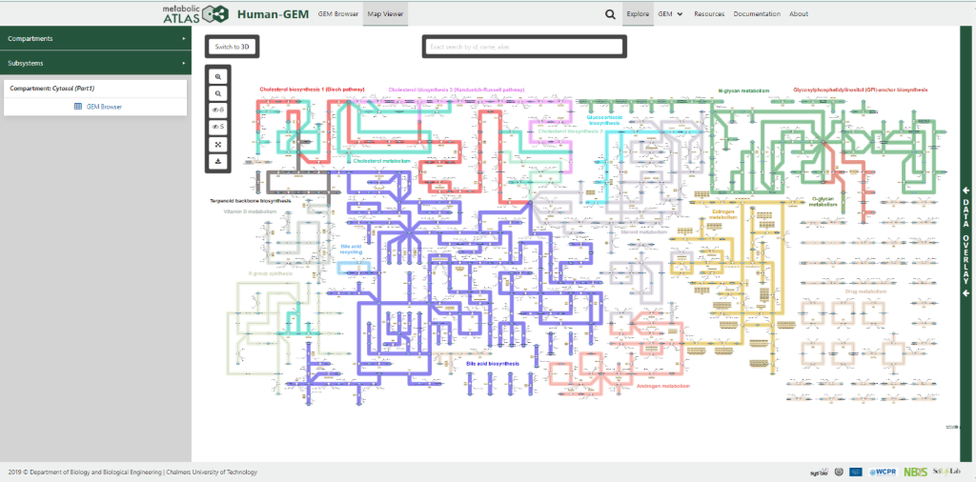

In the above page you can see the following:

**Map Viewer**

**2D Viewer**

2D SVG maps are provided for integrated GEMs. They represent either a cell compartment or a subsystem/pathway. While a very high percentage of the reactions in the model are represented on the 2D maps, some may be unavailable.

Three buttons on the top left of the UI allow users to zoom in, zoom out and show/hide the genes on the current map.

Users can interact with the maps by clicking and dragging the mouse to pan the view or using the mouse wheel to zoom in/out.

A search function is available for 2D maps using the search bar. The window will zoom and center on each component found. Click the 'highlight' button to color all found components on the maps in red. To remove the highlight, simply clear the search bar.

The SVGs are interactive; click on a node (metabolite, reaction, gene) or a subsystem to load some of its information in the sidebar. Additonal information on the corresponding selected element can be accessed by clicking the *GEM browser* button.

**3D Viewer**

3D renderings of the metabolic network are automatically generated from the GEM data. This 3D graph contains all the reactions in the model, grouped by cellular compartment or subsystem.

Interaction with the 3D graph is possible using the mouse by holding left-click and moving the mose to rotate the view, right-click to pan, and use the mouse wheel to zoom in/out.

Users can also hover a node to view its name/id or left-clik on a node (once the graph has stopped moving) to display some of its information in the sidebar. Additonal information on the corresponding selected element can be accessed by clicking the *GEM browser* button.

**Data overlay**

Gene expression levels for genes from [The Human Protein Atlas v18](https://www.proteinatlas.org/about/releases#18) can be loaded using the *Data overlay* sidebar on the right side. Once selected, the RNA levels corresponding to the chosen tissue will be used to color each gene on the respective map, as shown in the legend. To clear the RNA levels, select the *None* option. RNA levels are available for both the 2D and 3D Map Viewer. The data is obtained from version 18 of the Protein Atlas with the units in log2(TPM+1) associated with a gradient colorbar.

The *Data overlay* sidebar allows for the upload of user-generated data in TSV format. If the file is parsed correctly, the file name will be highlighted green; in case errors are detected, it will be highlighted red. The expected format is at least two columns with headers using tab delimiters. For an exact description of the TSV file format [see the Wiki page](https://en.wikipedia.org/wiki/Tab-separated_values). The first column has to contain the gene IDs, identical to the ones in the model. Any missing genes or missing values will be assigned an "n/a" value and highlighted in gray. The rest of the columns act as data series, with each column being a new series, as shown in the example to the right. The headers of these data series will be shown automatically in the dropdown options for the uploaded data. The values are expected in TPM.

If multiple data are selected in the *Data overlay* sidebar, the overlay will switch to the comparison mode, using a differently colored legend for the log fold change between the selected data.

1. Going back to previous page now open Zebrafish GEM browser

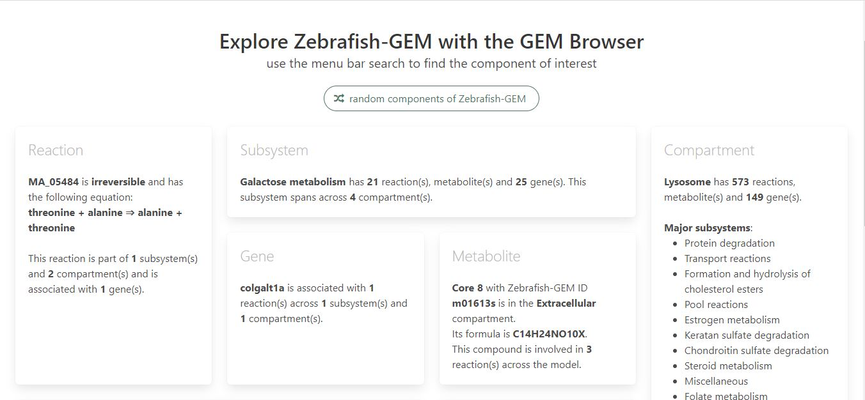

5. Open Zebrafish map viewer

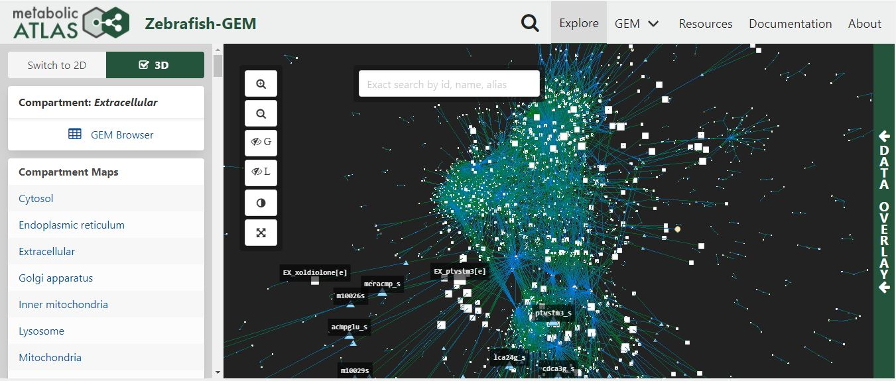

**Insilico system biology practical**

**Experiment :** Determine protein-protein interaction information using STRING.

Submitted by: SUDHANSHU AHUJA

M.Sc BIOINFORMATICS

Enrollment number: A0500320002

**EXPERIMENT- 14**

**Aim**: Determine protein-protein interaction information using STRING.

**Theory:**

Protein–protein interactions (PPIs) are the physical contacts of high specificity established between two or more protein molecules as a result of biochemical events steered by electrostatic forces including the hydrophobic effect.

STRING is a database of known and predicted protein-protein interactions. The interactions include direct (physical) and indirect (functional) associations; they stem from computational prediction, from knowledge transfer between organisms, and from interactions aggregated from other (primary) databases. The STRING database contains information from numerous sources, including experimental data, computational prediction methods and public text collections. It is freely accessible and it is regularly updated. It is accessed through <https://string-db.org/cgi/input.pl?sessionId=OIDuUN3jFz7b&input_page_show_search=on>

**Procedure:**

1. Open string database, and go on the search URL.
2. Enter the protein name and the name of the organism. Examples are also available above the search bar.
3. After entering the query, you will be taken to a page that shows the PPI along with the legend, and links to different databases for the proteins shown in the network.

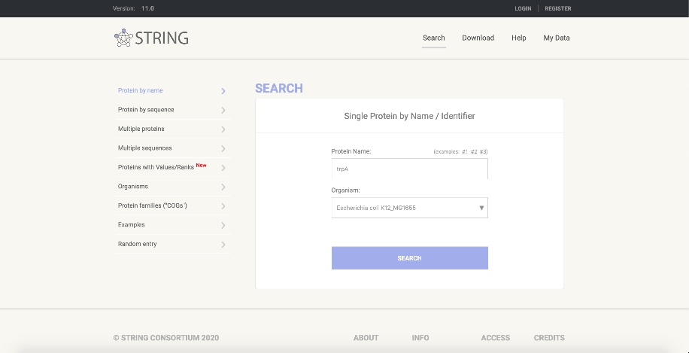

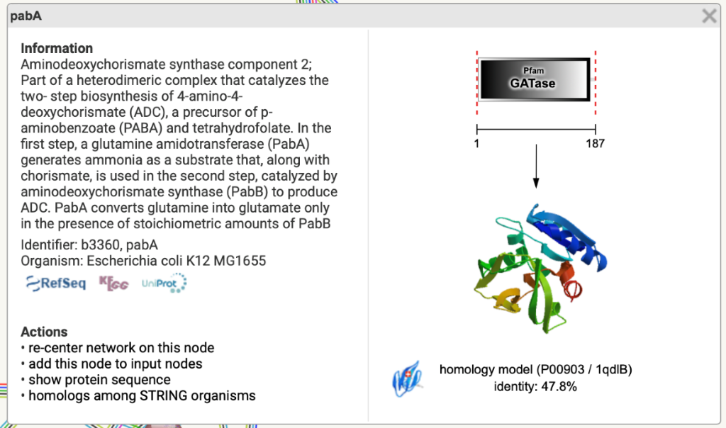

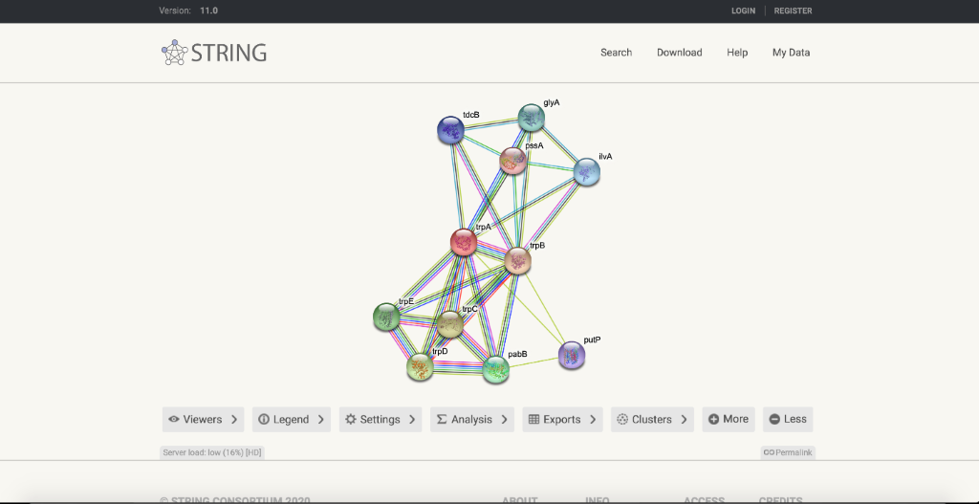

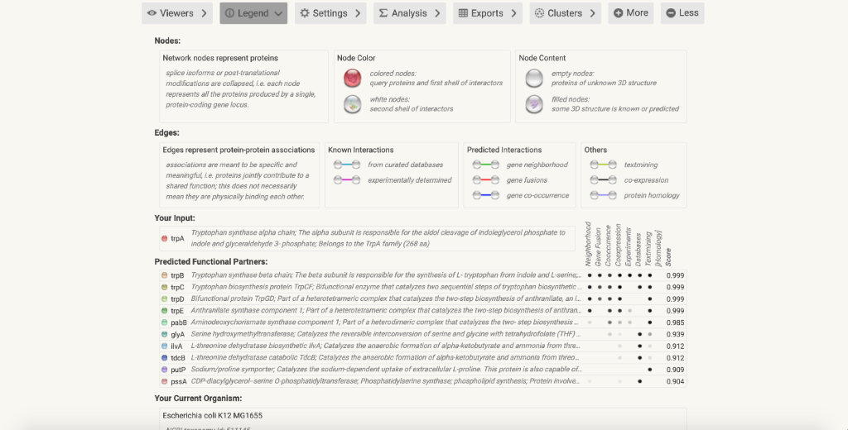

**In-silico system biology- (PRACTICAL)**

**EXPERIMENT :** Determine protein-protein interaction information using APID.

**Submitted by: PRIYANKA PILANIA**

**M.Sc BIOINFORMATICS**

**Enrollment no: A0500320009**

**Aim**: Determine protein-protein interaction information using APID.

**About APID:**

* Agile Protein Interaction DataAnalyzer (APID) is an interactive bioinformatics web tool developed to integrate and analyze in a unified and comparative platform main currently known information about protein–protein interactions demonstrated by specific small-scale or large-scale experimental methods. At present, the application includes information coming from five main source databases enclosing an unified sever to explore >35 000 different proteins and 111 000 different proven interactions. The web includes search tools to query and browse upon the data, allowing selection of the interaction pairs based in calculated parameters that weight and qualify the reliability of each given protein interaction. Such parameters are for the ‘proteins’: connectivity, cluster coefficient, Gene Ontology (GO) functional environment, GO environment enrichment; and for the ‘interactions’: number of methods, GO overlapping, iPfam domain–domain interaction. APID also includes a graphic interactive tool to visualize selected sub-networks and to navigate on them or along the whole interaction network.
* It as accessed through <http://cicblade.dep.usal.es:8080/APID/init.action>
* APID server was built with a **protein** and **proteome-centered** strategy, using **UniProt** database as the main guide to identify and handle all the proteins and to map them into the reference proteomes of each species (based on the new proteomes resource that UniProt has recently developed: <http://www.uniprot.org/proteomes/>).

**Interaction information:**

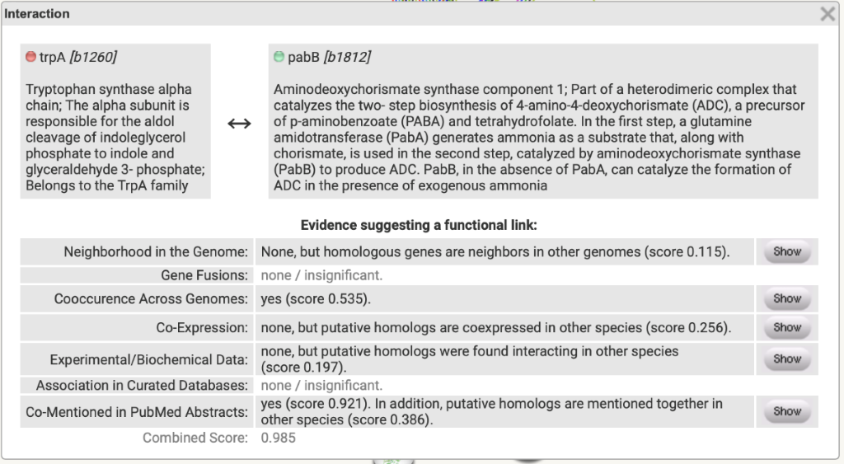

Agile Protein Interactomes DataServer: It has curated protein interactomes, PPIs demonstrated by experimental methods, graphic interactive tool to visualize selected sub-networks. It uses various databases involved such as DIP, PDB, SwissProt, and annotation databases such as Reactome.

**PROCEDURE:**

1. In APID database, we can get the information about the interactomes at different quality levels and coverage in PROTEOMES, we can either search one particular protein or list of different proteins and we can also search for publications using pubmed ID. Here, in the protein search section we enter the protein name and click on search.

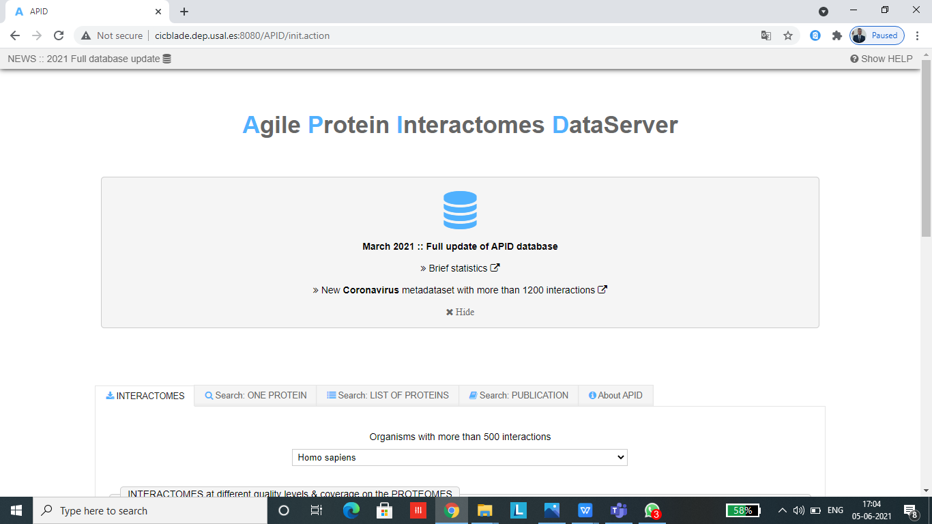

1. Upon searching for an interactome at a given level, a text file in tabular format is downloaded onto the system. The table contains UniProt name and ID, and 3D structure.

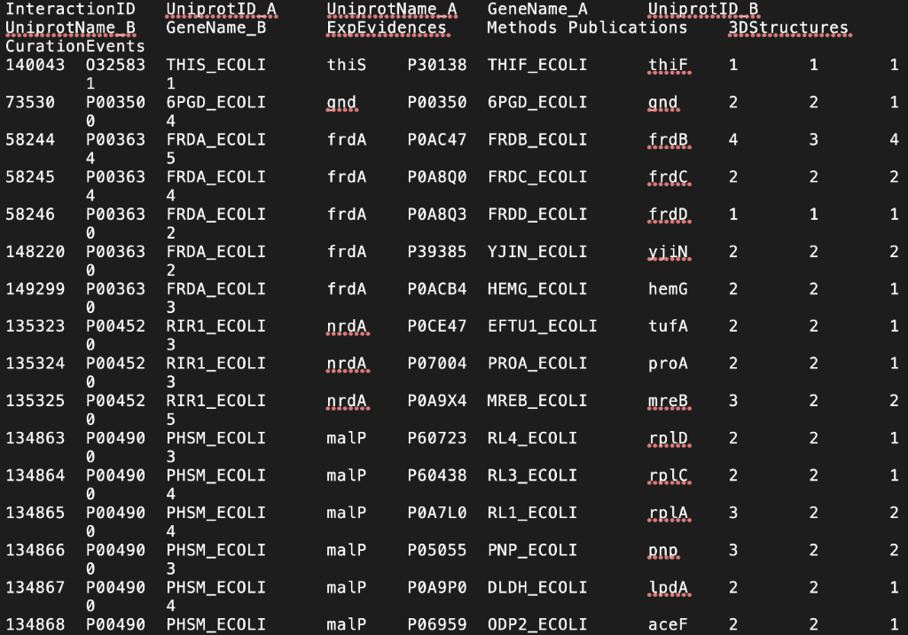

1. We can look for the protein interactions by clicking on interactions.

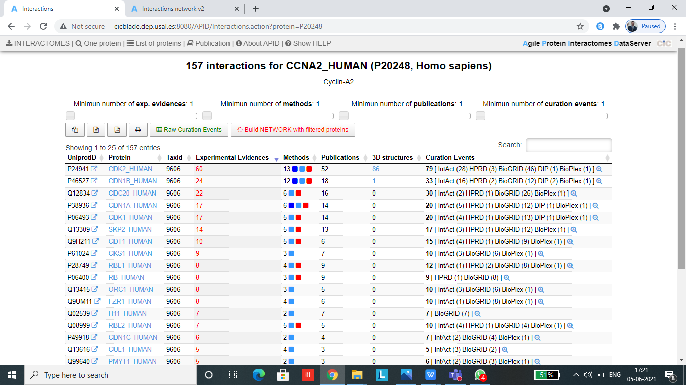

1. We can also look for the curation events.

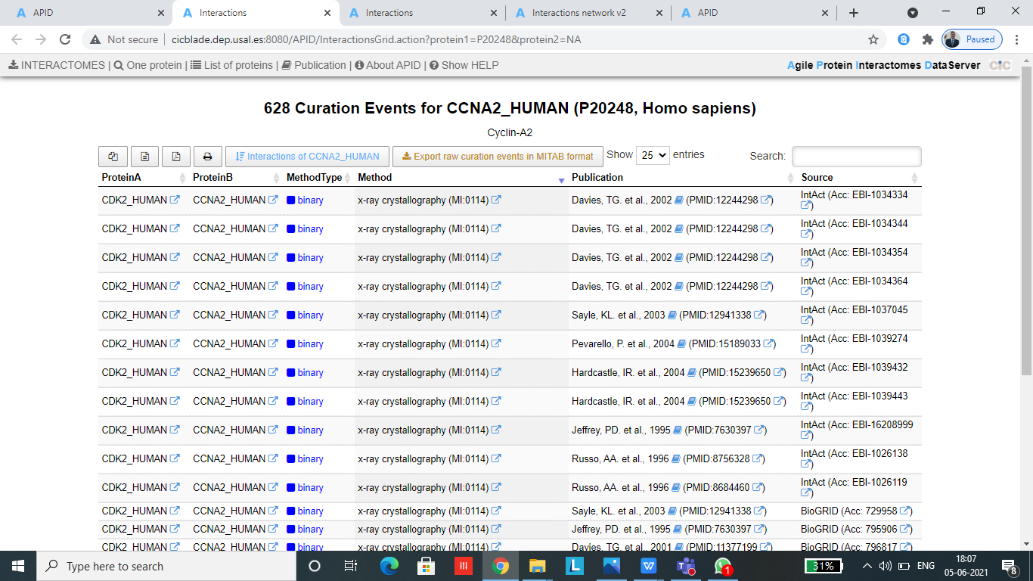

1. We can then build network by using the filtered proteins and can look for the interactions.

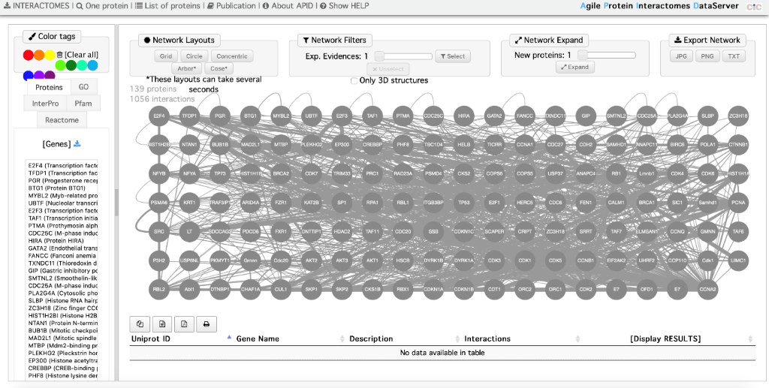

1. Upon searching for a specific protein, we can come across the above with all the relevant information.
2. We can also access the interaction network as well as take a look at the genes available. We can click on any individual protein in order to obtain information about it as well as the interactions.
3. APID also allows users to build interactome for a list of proteins. This is done so through preparing a list of proteins using UniProt name identifiers or ENTREZ. Once the proteins are found, the list will be shown on a new window. Using this list, a protein network can be built.

**INSILICO SYSTEMS BIOLOGY PRACTICALS**

**EXPERIMENT – 16 (CellDesigner)**

**Aim:** To upload,import/export SBML file of MAPK pathway (from PANTHER database) and glycolysis (from BioModels database) in CellDesigner

**Tools used:** [**http://www.ebi.ac.uk/biomodels-main/**](http://www.ebi.ac.uk/biomodels-main/)

[**http://pantherdb.org/**](http://pantherdb.org/)

CellDesigner, [www.celldesigner.org](http://www.celldesigner.org/)(download the latest version 4.4)

**Theory**: CellDesigner is a structured diagram editor for drawing gene-regulatory and biochemical networks. CellDesigner can store all the model information and interaction informations inSBML file format. The model which has been created in the CellDesigner, will saved it in the complete SBML document.Synergistic integration characterizes systems biology of theory, computational modeling, and experiment. The aim in developing CellDesigner is to supply a process diagram editor with the standardized technology (SBML in this case) for every computing platform, so that it could confer benefits to as many users as possible. The main standardized features that CellDesigner supports could be summarized as “graphical notation”, “model description” and “application integration environment.” The standard for graphical notation plays an important role for efficient and accurate dissemination of knowledge and the standard for model description will enhance the portability of models between software tools.

**CellDesigner = SBML + SBGN + Simulation + Databases Connections**

One of our aims is to use CellDesigner as a simulation platform, and thus integration capability with native simulation library has been implemented. SBML ODE Solver could be invoked directly from CellDesigner, which enables us to run ODE-based simulations. The SBML ODE Solver Library (SOSlib) is a programming library for symbolic and numerical analysis of chemical reaction network models encoded in SBML.CellDesigner, a process diagram editor for gene-regulatory and biochemical networks based on standardized technologies and with wide transportability to other SBML-compliant applications and SBW-enabled modules.

The overriding advantage of CellDesigner is that it uses open and standard technologies. The models created by CellDesigner could be used on many other (over 100) SBML-compliant applications, and its graphical notation system will make the representation of models in a more efficient and accurate manner.

The advantages of CellDesigner over other pathway design tools could be summarized as follows:

* Based on standard technology (i.e., SBML compliant and SBW enabled);

* Supports clearly expressive and unambiguous graphical notation systems (SBGN),which is aimed at contributing to eventual standard formation;
* Runs on many platforms (e.g., Windows, MacOS X, Linux).

**Procedure:**

**A. To upload a model from database**

**Step 1: Open CellDesigner :**

Click on CellDesigner icon from your desktop or go to programs and select the CellDesigner on a windows machine.

**Step 2: Select the file from the list of databases :**

Go to CellDesigner Database menu and click on open. It is easy to open the SBML file which has been saved in these databases. Upload the models from these databases by selecting it.

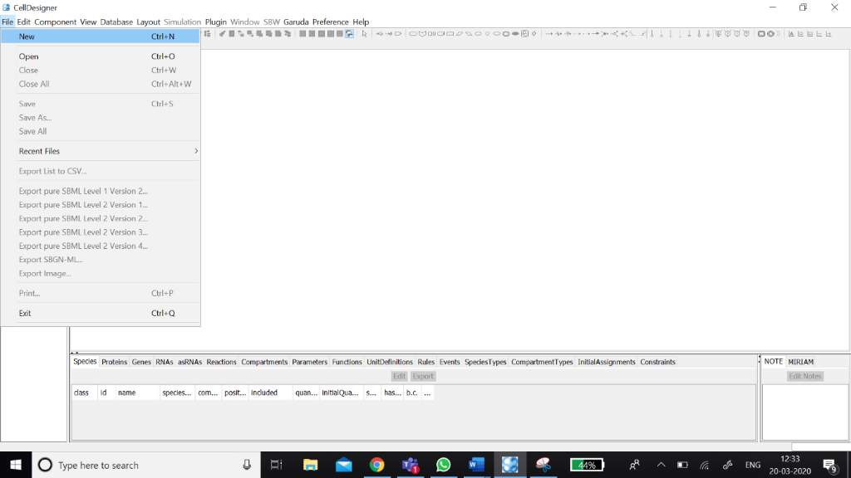

**Another way to import a model**

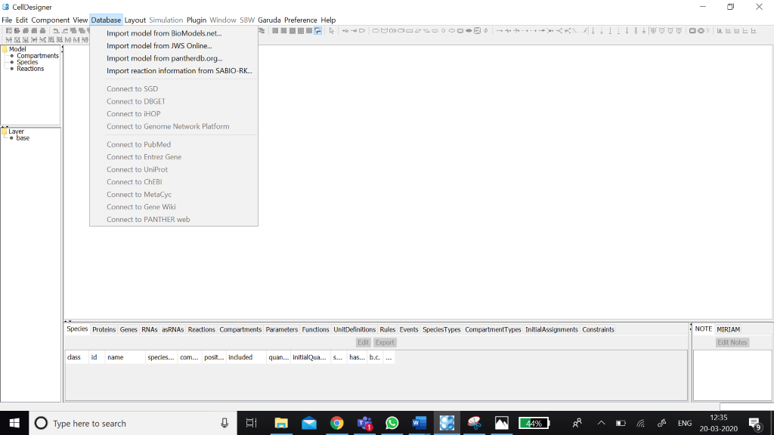

**Step 3: Select the file to be open :**

Select the SBML file which has to be open.

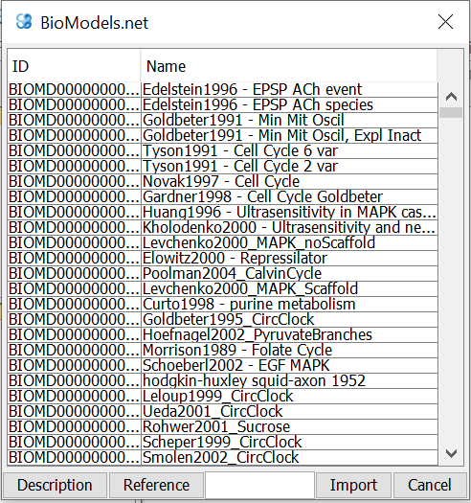

**Step 3: Visualizing and exploring the SBML model using CellDesigner :**

Click on the file which has to be open using CellDesigner and write down the important observations with screenshots.

**Interface of Cell Designer:**

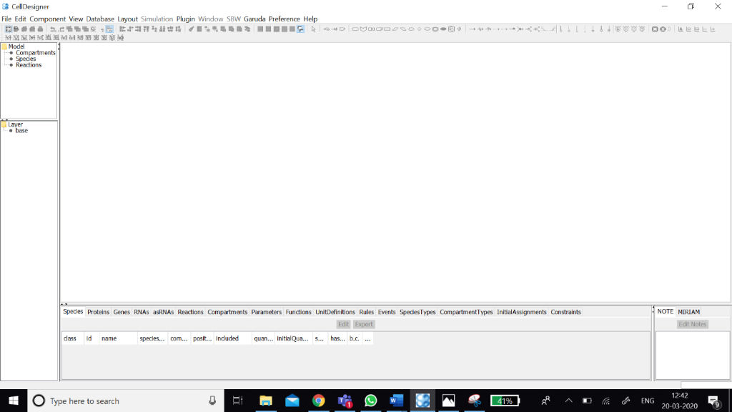

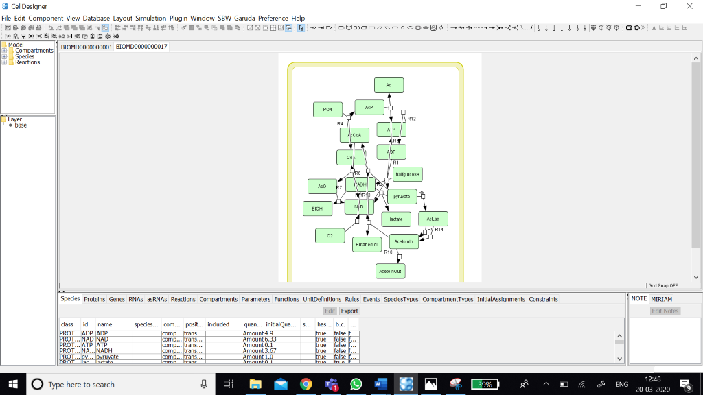

* Drag the borders (left or right) of the Draw Area to change the area size.
* **Zoom**

You can change the zoom view of the model by clicking the following icons.

**Selecting a Component**

* A component is a general term for a Species (including a Complex), a Reaction, or a Compartment. Thus, any shape you see on the Draw Area ---a rectangle, an oval, or a line segment--- is a component.

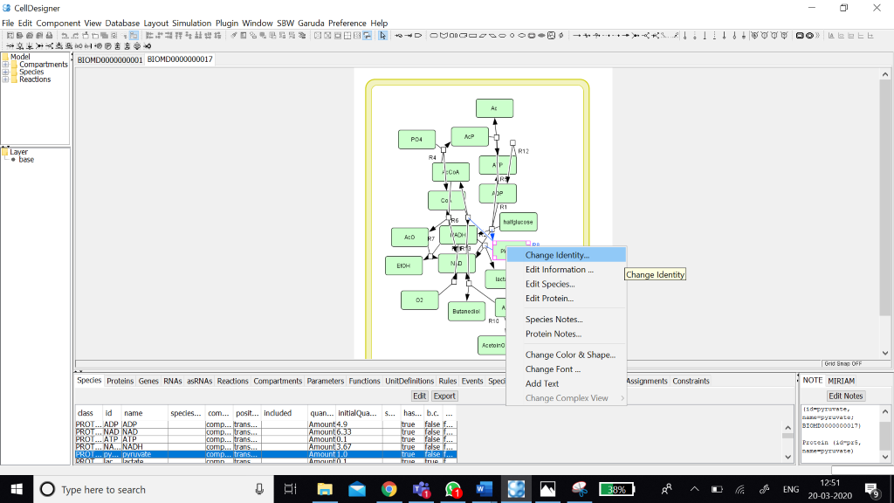

* A Compartment is a container for other components and can also hold other Compartments in it. A Compartment represents a generic bounded container, such as a cell or an intracellular compartment. The change in its size and shape only affects its appearance on canvas, and has no effect on semantics of biochemical and gene networks.

**Species and Reactions:** A Species represents, for example, a protein or some othermolecule in a biochemical network, or a gene in a gene regulatory network. A Reaction represents a state transition of the connected Species such as a biochemical reaction, an interaction between proteins, and a regulatory relation between genes.

**Close a Model: To close a file without saving any changes.**

Select File – Close.

**Macros**

To draw the diagram easier, some of the most frequently used components sets are available as “macros”. You can select the macros from the tool bar to draw the following components set.

**To change the default settings of the color and shape**

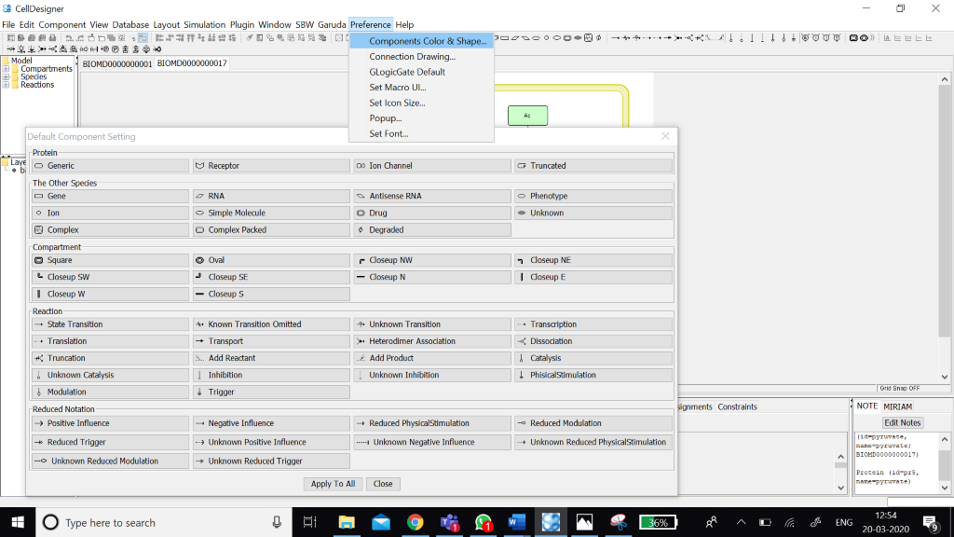

**To change the layout of your working model**

On the Layout menu, select one of the layout types

* **Orthogonal Layout**

* **Organic Layout**

* **Smart Organic Layout**

* **Hierarchic Layout**

* **Incremental Hierarchic Layout**

* **Circular Layout**

* **Tree Layout**

* **Edge Router**

**Orthogonal Layout:**

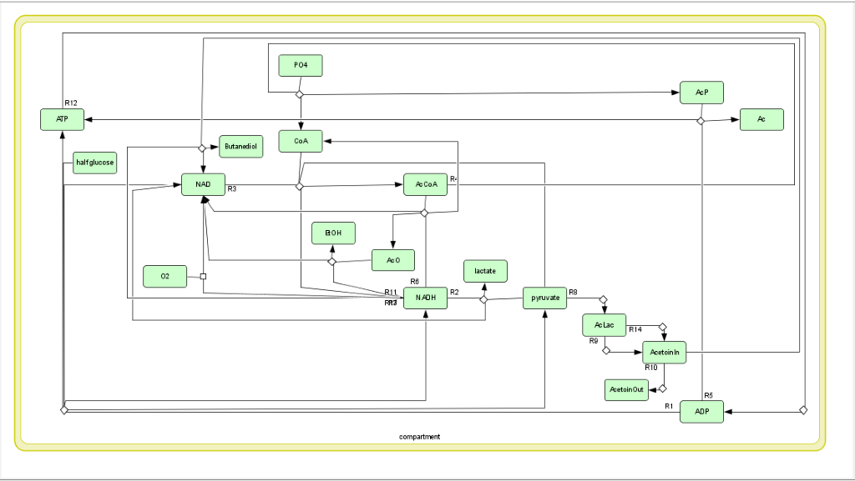

**Procedure to import MAPKinase pathway in cell designer:**

1. Import model from panther database.

Go to Database tab and select “Import model from pantherdb.org

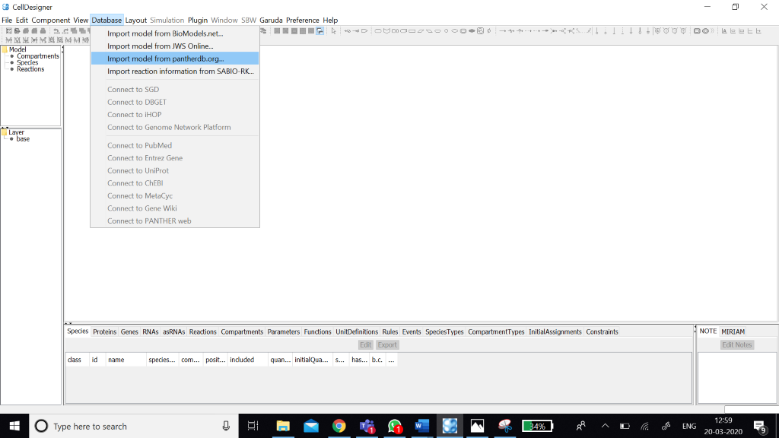

**2.** Type MAPK in the white skinny search box. Select p38 MAPK pathway and click on ‘IMPORT’ button.

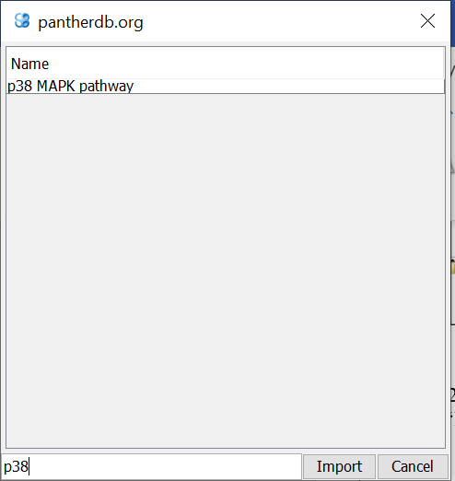

**Results**:

Click on Compartments in the tree area. Two compartments are displaying i.e. cytoplasm and nucleus. Click on cytoplasm, all the components in the model within the cytoplasm gets highlighted and similarly when click on nucleus.

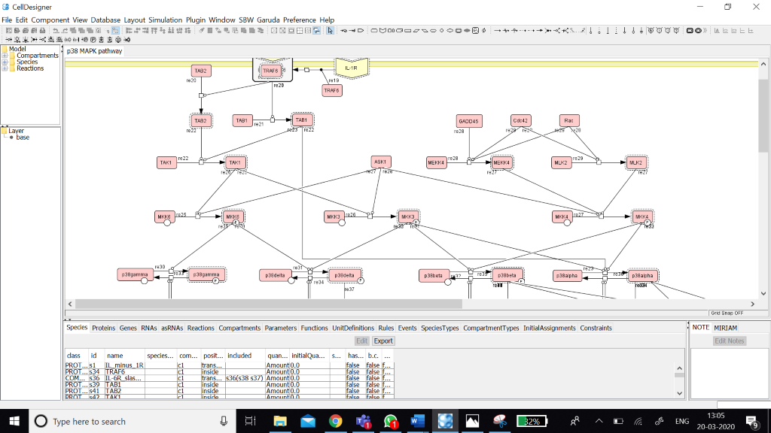

**LAYOUT NOTE:**

**1.Species:** All the components present in the model is annotated in the species table. It annotates class(protein/rna/dna/complex), ID no, name, species type, compartment (c1/c2), position (transmembrane/inside/inner surface) quantity, initial quantity, substance units, has only substance units, b.c., constants. 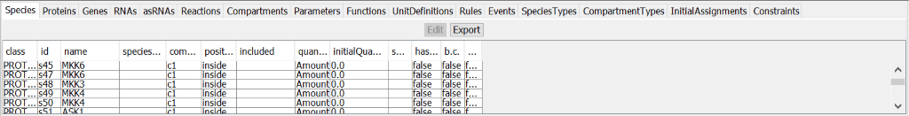

We can export this table by just clicking on “EXPORT” button.

**2.Click on Proteins tab:** It provides what type of proteins present in the model (receptor/generic) along with the name and ID of the proteins.

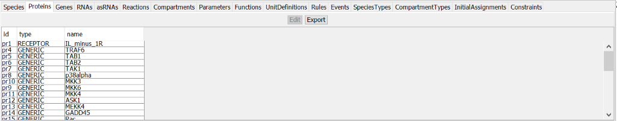

**3.Click on Reactions tab:** All the reactions within the model is annotated in the reaction table. The table contains type of the reaction, ID no, name, reversible(F/T), fast(F/T), reactants, products, modifiers, and math.

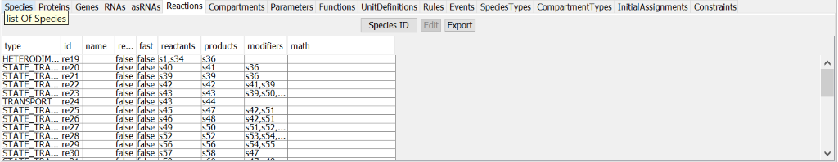

**4.Click on Unit Definitions:** It contains ID(substance/volume/area/length/time), name and corresponding unit of given IDs. 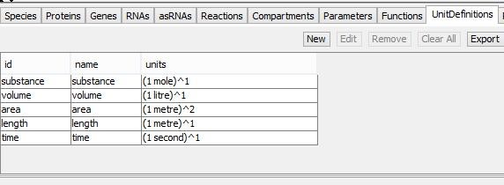

**5.Export Image:** Go to FILE menu and click on ‘EXPORT IMAGE’ and select file type (JPEG/PNG).

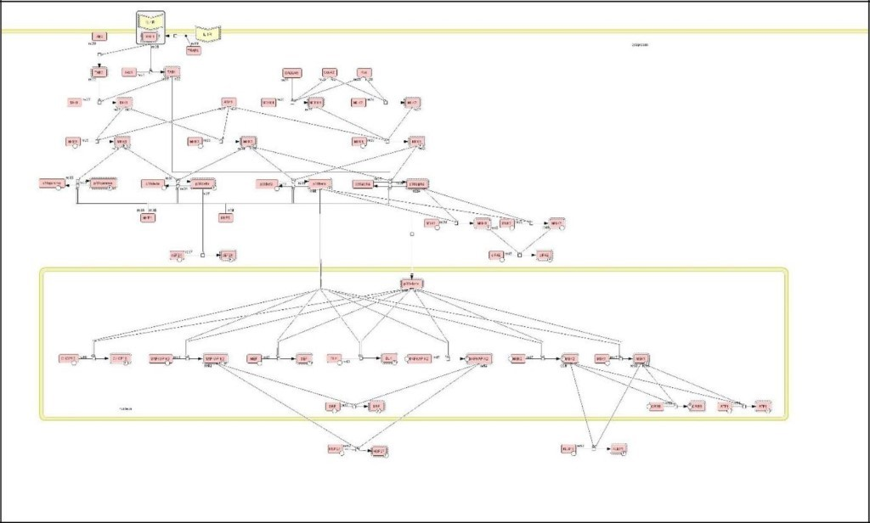

**Part 2**

**Theory:** Reaction kinetics is the study of how fast chemical reactions take place, what factors influence the rate of reaction and what mechanisms are responsible. Many variables can affect the reaction rate including temperature, pressure, and composition. A chemical

reaction is usually depicted in the form of a chemical equation which describes the

transformation of one or more reactants into one or more products. The reactants appear on

the left of the equation and the products on the right.

The rate of reaction, v, is often found to be proportional to the concentration of species A, or:

v = kA

This property is often called the law of mass-action and the corresponding kinetics called

mass-action kinetics. The proportionality constant, k, is called the rate constant.

**Procedure:**

**1. Assigning Reaction ID**

1.1 To show Reaction ID on Draw Area

On the View menu, select Show Reaction ID

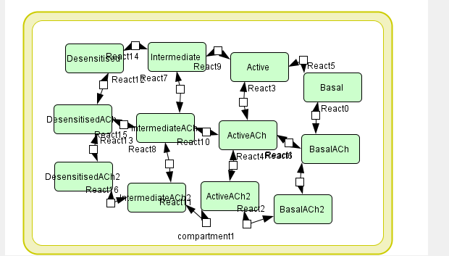

**2. Editing a reaction**

2.1 Right click on a Reaction.

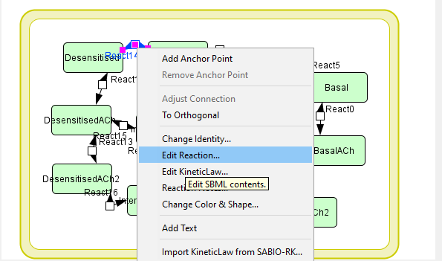

2.2 Select a menu item from the right-click context menu.

2.3 Select a menu item depending on which value you want to edit.

2.4 Selecting Change Identity will show you Change properties of the reaction dialog.

2.5Selecting Edit Reaction will show you Reaction dialog.

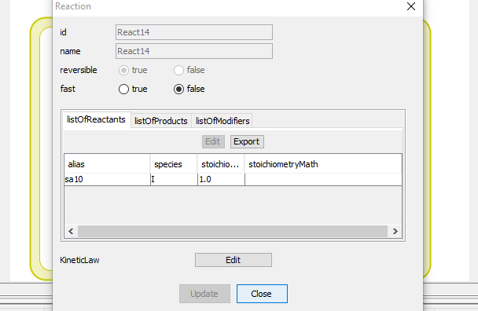

**3. Reactions List**

You can view all the data concerning a Reaction in the Reactions tab in the List Area. This is

useful when you want to check all the Reactions specified in the model.

You can swap columns by drag-and-drop.

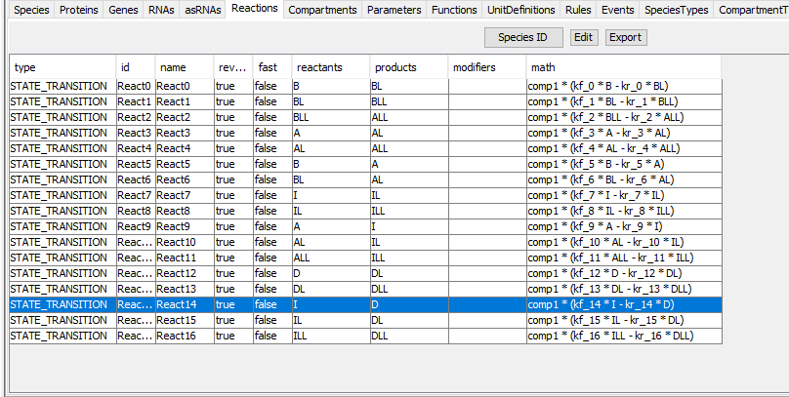

You can export the contents of the list into .CSV file format by clicking Export button on the top

of the list.

**4. Assigning Kinetic Law**

You can specify a Kinetic Law to a Reaction using the Kinetic Law dialog. You can input your

own math functions, or you can use the predefined functions from the Kinetic Law dialog.

4.1. To add a Kinetic Law to a Reaction

4.2. In the List Area, click on the Species tab.

4.3 Select the row for the Protein A.

4.4 Double click on the cell under InitialQuantity column.

4.5 Set the value to “0.1”.

4.6 In the List Area, click on the Reactions tab and double click on the STATE_TRANSITION Reaction to open the Reaction dialog.

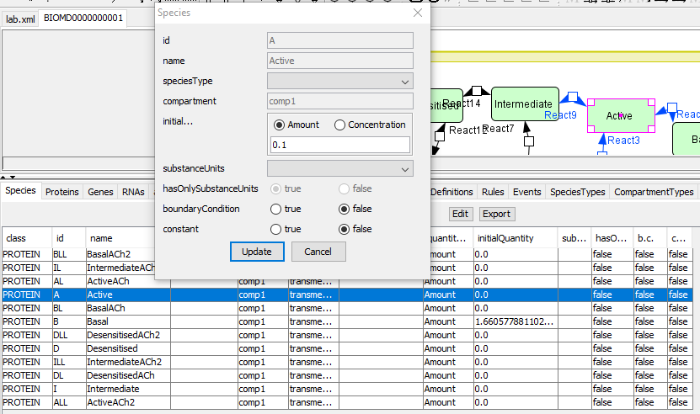

**5. Click KineticLaw Create button**

Instead of doing the steps 5 and 6, you can also click on the Reaction with the right

mouse button, and then select **Edit KineticLaw...** menu.

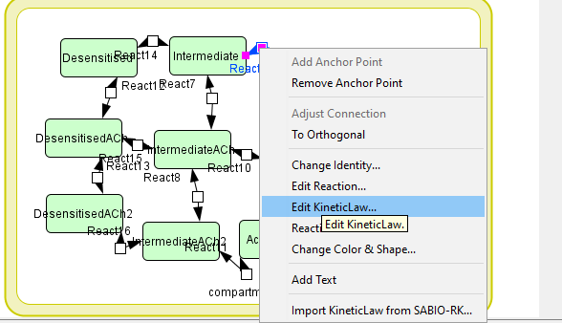

6. The KineticLaw dialog will open.

7. In the Predefined Functions pane, click Mass_Action_Kinetics.

8. The Formula dialog will be displayed.

9. Enter “0.3” in the k text box, then click OK.

10. See that “s1*k1” has been entered in math field, then click Update, then Close.

11. In the Reaction dialog, click Close.

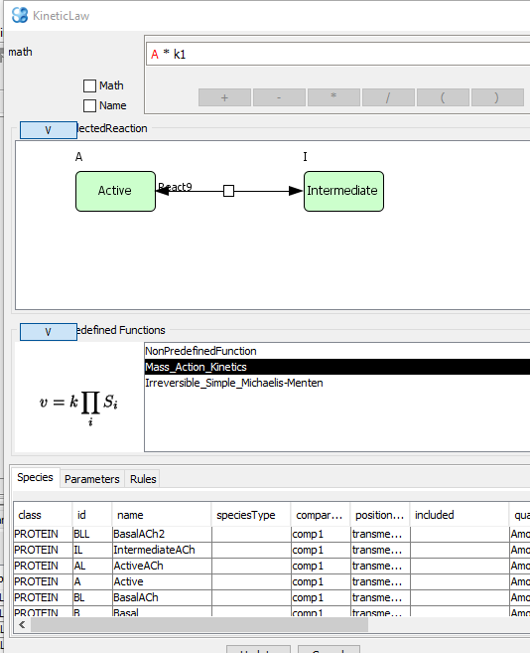

**The Kinetic Law for the Reaction was successfully set.**

**Now you can run the simulation.**

**Part 3**

**Aim:** To create a basic model in CellDesigner

**Software:** CellDesigner version 4.4

**Theory:** CellDesigner can store all the model information and interaction informations in SBML file format. The model which has been created in the CellDesigner, will saved it in the complete SBML document. Synergistic integration characterizes systems biology of theory, computational modeling, and experiment. The aim in developing CellDesigner is to supply a process diagram editor with the standardized technology (SBML in this case) for every computing platform, so that it could confer benefits to as many users as possible. The main standardized features that CellDesigner supports could be summarized as “graphical notation”, “model description”, and “application integration environment.” The standard for graphical notation plays an important role for efficient and accurate dissemination of knowledge and the standard for model description will enhance the portability of models between software tools.

**Steps:**

1. Open CellDesigner

2. Click on the CellDesigner icon from your desktop.

3. Create a new model

In the menu, choose [File] => [New].

1. A window opens. Name the file: test.

5. Set the dimensions. By default, the dimensions are set to 600 x 400.

6. Click [OK].

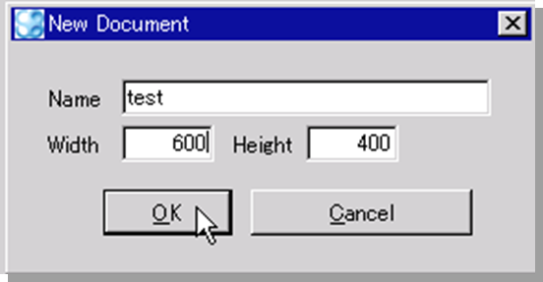

1. Create a reaction
2. Add two proteins: A and B.
3. Click in the "Species" menu bar on the protein shape.



A window pops up.

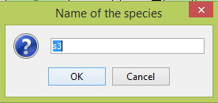

1. Name the protein A.
2. Repeat the process and name the second protein B.
3. Click in the "Reaction" menu bar on state transition.
4. Go back to the drawing frame and click on protein A.
5. Several grey squares appear around the protein, choose one of them from which the arrow will start.
6. Click on protein B and choose a grey square on which you want the arrow to point.
7. Click Add anchor point

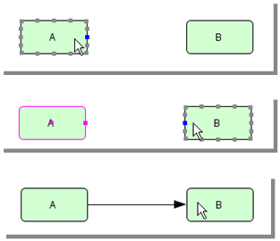

A line links two species. The anchor points are the points from which each segment of a line starts or ends. That way, more freedom is given to the user to place the species where the user wants.

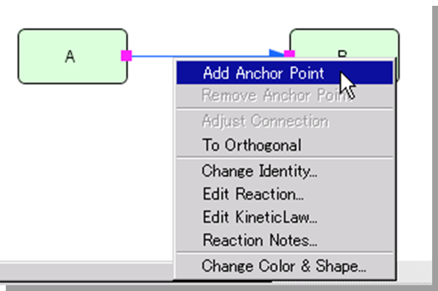

1. Click right on the line where you want to add the anchor point.
2. Choose [Add Anchor Point].
3. Repeat the process as many times as needed.

**Note:** if you choose [To Orthogonal] as opposed to [To Polyline], the segments will automatically be arranged according to the orthogonal grid. However, the anchor points can only be added when the mode is Polyline.

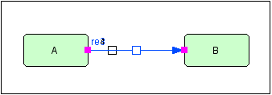

1. Add catalysis reaction
2. Add protein C.
3. Click on "Catalysis" in the "Reactions" menu bar.

23.Select protein C on the square of the transition reaction that links A to B.

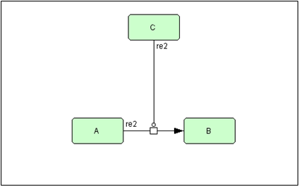

24. Set active state

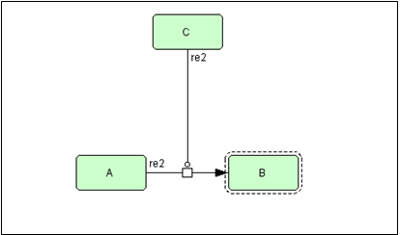

24.1 Select protein B.

24.2 From the menu [Components], select the option [Set Active].

1. Change color

25.1 Right-click on protein C.

25.2 Select [Change Color & Shape]

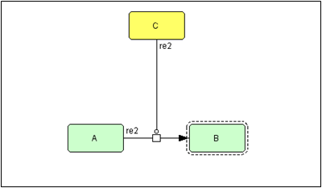

26. Insert compartment

26.1 Click on the "Compartment" icon in the drawing menu bar.

26.2 Drag the mouse cursor to specify the area of the compartment around our small network.

26.3 Name the compartment: Cell.

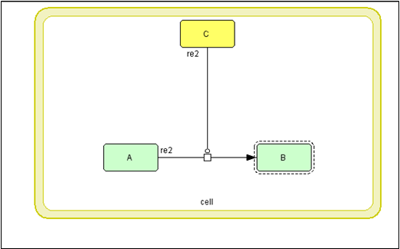

27. Add residue

27.1 Create new model.

27.2 Name it: test2.

28. Create protein A

28.1 Select protein A in [Proteins] Tab

28.2 Click [Edit] button

(or right-click on the protein and choose [Edit Protein])

28.3 Click on the [add..] button in the [Protein] dialog

28.4 Name the residue (tst1).

28.5 Click on the [Close] button. Click on the [Update] button.

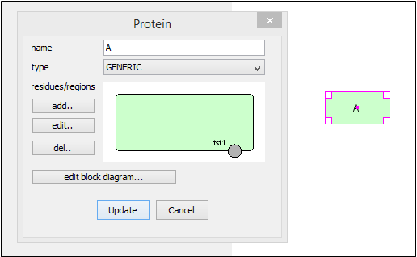

**29. Making a Residue network**

29.1 Copy & Paste protein “A” and then draw the “State Transition” arrow from “A” to “A”.

29.2 Right-click on “A” (right side) and select [Change Identity...].

(or double-click on the protein).

29.3 Click on the residue “tst1” in the Dialog window.

29.4 Select [phosphorylated] to modify the state of the residue.

**29.5 Click on the [Apply] button.**

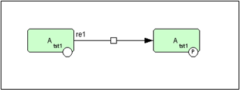

**30. Changing position of the residue**

30.1 Select protein “A” in [Proteins] Tab (lower panel).

30.2 Click [Edit] (you need to click on the protein in the list to be able to edit it).

30.3 Click on residue “tst1” in Dialog.

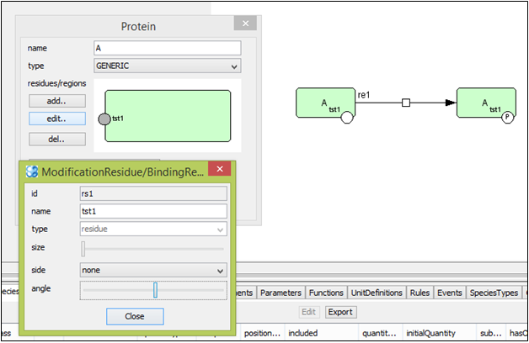

30.4 Click [edit...].

30.5 Drag [angle] slidebar (or you can also click on the residue, hold the mouse and drag the residue where you want)

30.6 Update the changes.

**31. Creating complexes**

31.1 Create new model (test3).

31.2 Create Proteins “A” and “B”.

31.3 Copy and Paste both “A” and “B”.

31.4 Click on the [Complex] icon and create complex “C”.

31.5 Drag Proteins “A” and “B” into complex C.

31.6 Draw “Association” arrow.

(you can also use the macro to create a complex).

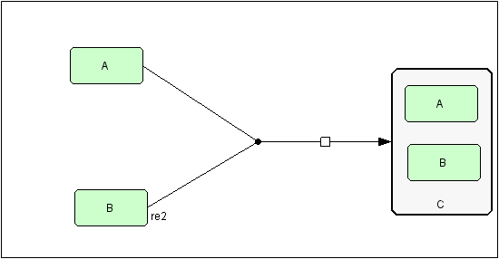

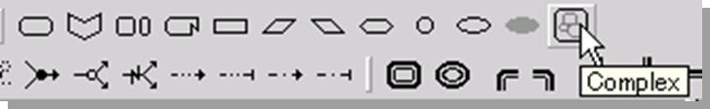

**32. Including genes and RNAs**

32.1 Create new model (test4)

32.2 Create gene, RNA and Protein

32.3 Draw “Transcription” and “Translation”

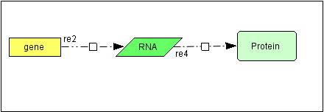

**INSILICO SYSTEMS BIOLOGY PRACTICALS**

**EXPERIMENT-17**

**Aim: Building and simulating models using COPASI.**

**Theory:**

* **COPASI**(Complex Pathway Simulator) is an open-source software application for creating and solving mathematical models of biological processes such as metabolic networks, cell-signaling pathways, regulatory networks, infectious diseases, and many others.
* History- COPASI is based on the Gepasi simulation software that was developed in the early 1990s by [Pedro Mendes](https://en.wikipedia.org/wiki/Pedro_Pedrosa_Mendes). The initial development of COPASI was funded by the [Virginia Bioinformatics Institute](https://en.wikipedia.org/wiki/Virginia_Bioinformatics_Institute), and the [Klaus Tschira Foundation](https://en.wikipedia.org/wiki/Klaus_Tschira_Foundation).
* Features- COPASI includes features to define models of biological processes, simulate and analyze these models, generate analysis reports, and import/export models in [SBML format](https://en.wikipedia.org/wiki/SBML).
* **Model definition**: Models are defined as [chemical reactions](https://en.wikipedia.org/wiki/Chemical_reactions) between molecular species. The dynamics of the model is determined by [Rate law](https://en.wikipedia.org/wiki/Rate_law) associated with individual reactions. Models can also include compartments, events, and other global variables that can help specify the dynamics of the system.
* **Tasks**: Tasks are different types of analysis that can be performed on a model. They include [steady-state analysis](https://en.wikipedia.org/wiki/Steady_state_(chemistry)), [stoichiometric analysis](https://en.wikipedia.org/wiki/Stochiometry), time course simulation using deterministic and stochastic simulation algorithms, [metabolic control analysis](https://en.wikipedia.org/wiki/Metabolic_control_analysis), computation of [Lyapunov exponent](https://en.wikipedia.org/wiki/Lyapunov_exponent), time scale separation, parameter scans, optimization, and parameter estimation.
* **Importing and Exporting**: COPASI can read models in [SBML](https://en.wikipedia.org/wiki/SBML) format as well as in Gepasi format. COPASI can write models in several different formats including the [SBML](https://en.wikipedia.org/wiki/SBML), source code in the [C](https://en.wikipedia.org/wiki/C_(programming_language)) programming language, [Berkeley Madonna](https://en.wikipedia.org/wiki/Berkeley_Madonna) files, and [XPPAUT](http://www.math.pitt.edu/~bard/xpp/xpp.html) files.
* COPASI is software used for the creation, modification, simulation and computational analysis of kinetic models in various fields.
* It is open-source, available for all major platforms and provides a user-friendly graphical user interface, but is also controllable via the command line and scripting languages. These are likely reasons for its wide acceptance.

**BIOMODELS:** BioModels is a repository of mathematical models of biological and biomedical systems. It hosts a vast selection of existing literature-based physiologically and pharmaceutically relevant mechanistic models in standard formats.

**Model:** The mitogen Activated Protein Kinase cascade is a prototypic example of behavior emerging from a system.

* Mitogen activated protein kinase (MAPK) cascades are ubiquitous and highly conserved signaling modules, found in almost all eukaryotes. MAPK cascades are involved in many cellular processes such as cell proliferation, differentiation, movement, survival etc.
* The response of a MAP kinase to an upstream signal is shaped by the whole cascade of successive phosphorylation.
* The prediction that such a cascade would engender ultra sensitivity is one of the great successes of mathematical modeling in biochemistry, made in 1981 by Albert Goldbeter and Daniel Koshland, a decade before the discovery of MAP kinase cascades.

**MAPK Cascade – Ultra sensitivity: BIOMD0000000009- Hung1996**

* Huang CY, Ferrell JE Jr. Ultra sensitivity in the mitogen activated protein kinase cascade. This was the first detailed model of MAPK signaling showing the effect of cascading phosphorylation steps on MAPK signaling.
* This model demonstrates that the cascade arrangement has unexpected consequences for the dynamics of the MAPK signaling
* All intermediate complexes for modeled explicitly with reactions using mass action kinetics. Parameters and concentrations estimated from experimental results. The rate equation of the cascade was solved numerically.

**PROCEDURE:**

a) Time course simulation

1. Download a model using the format SBML from the BioModels repository of EMBL (BIOMD0000000009).

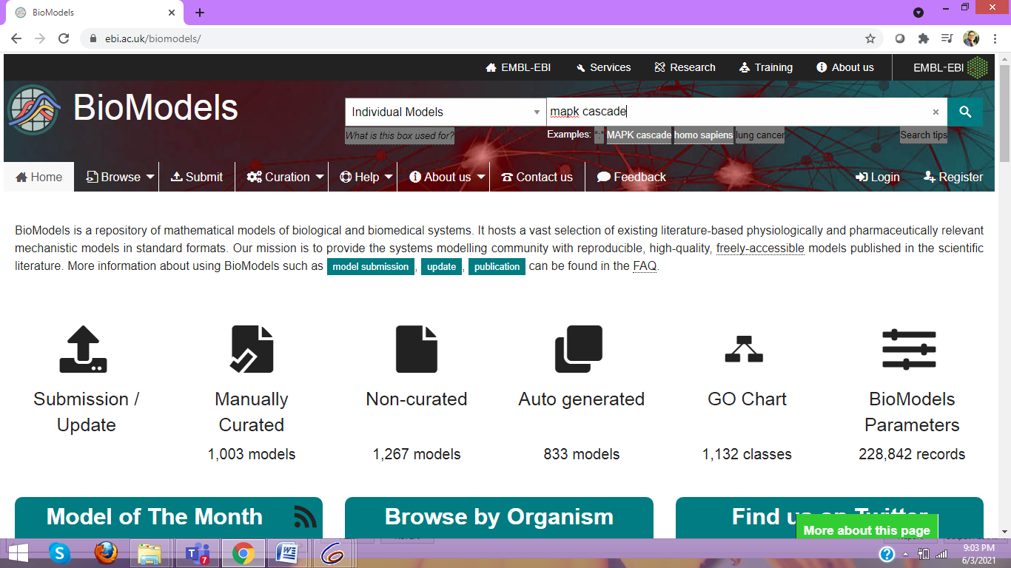

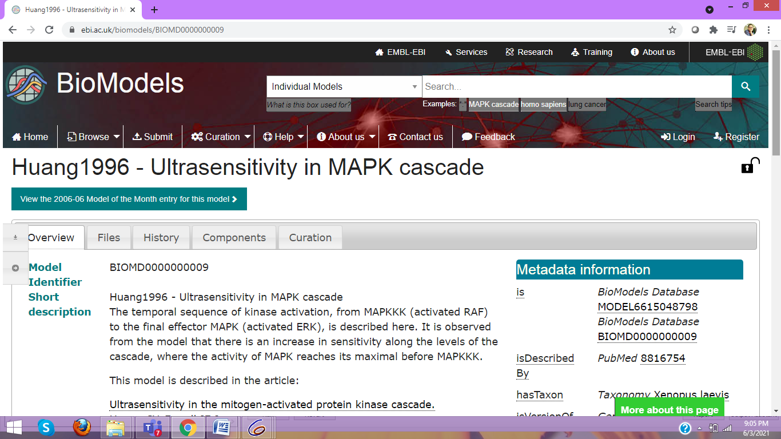

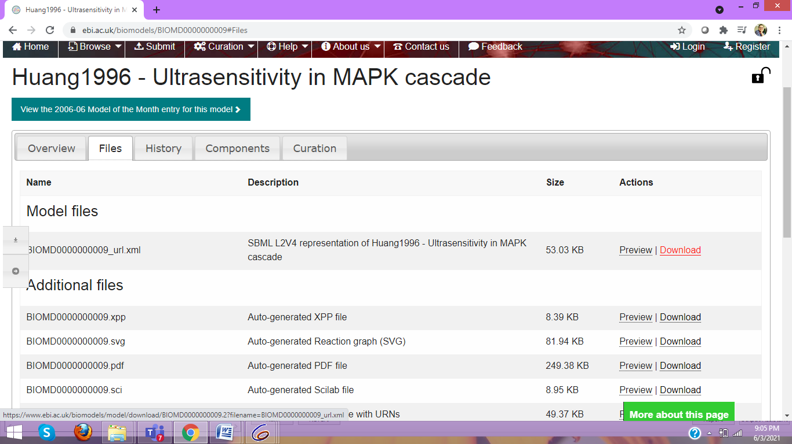

2. Import a biomodel in the SBML format (BIOMD0000000009).

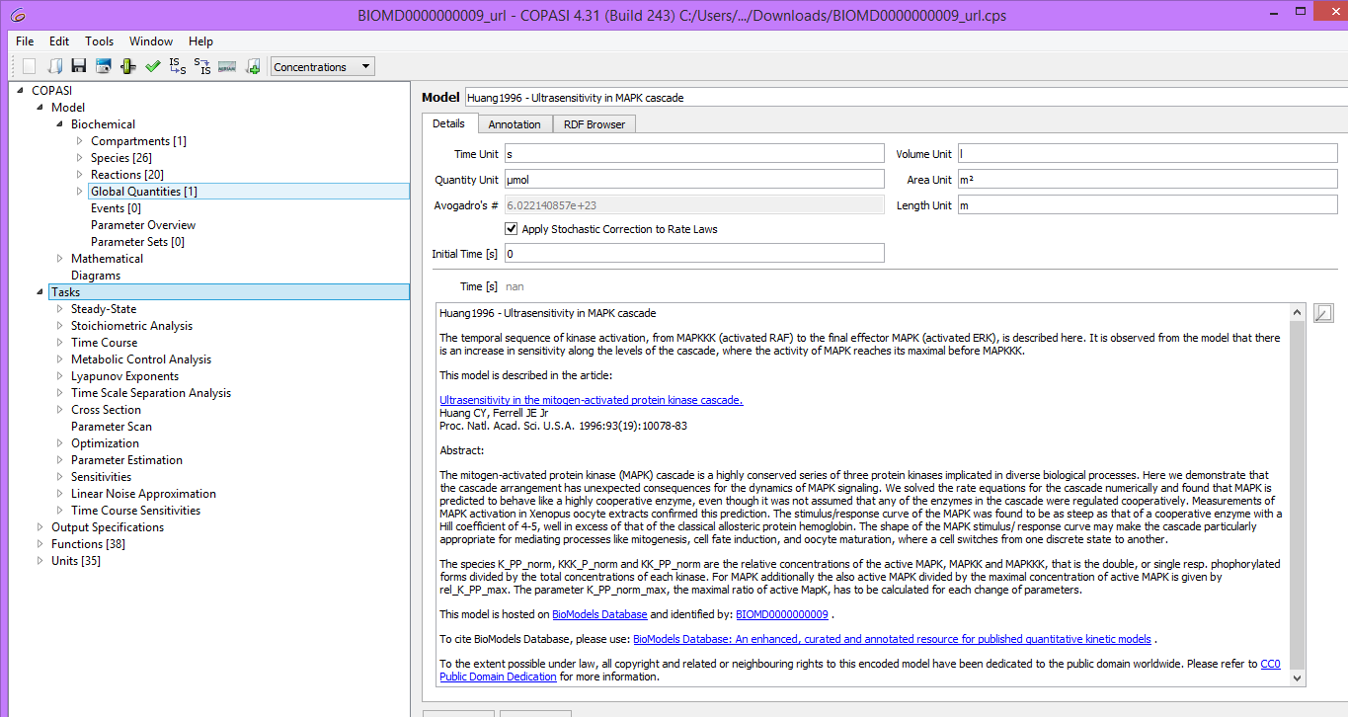

3. Explore the model and try to understand what happens in each reaction

4. Look at the “Annotation” tab of “Model”, a selected “Species” and a “Reaction”.

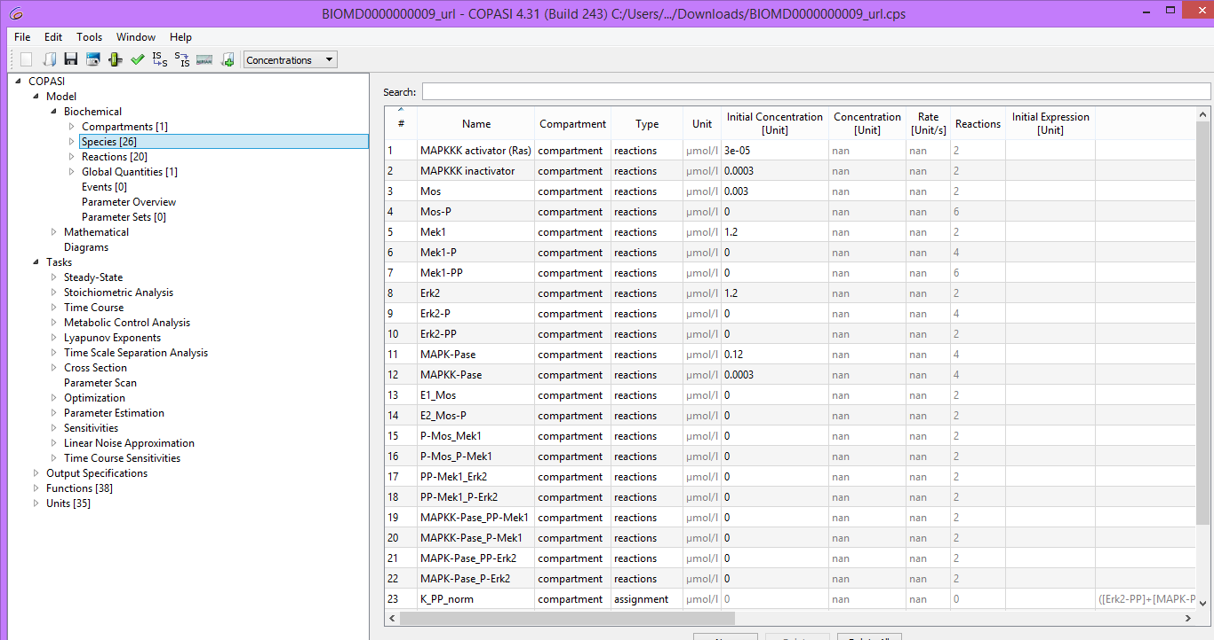

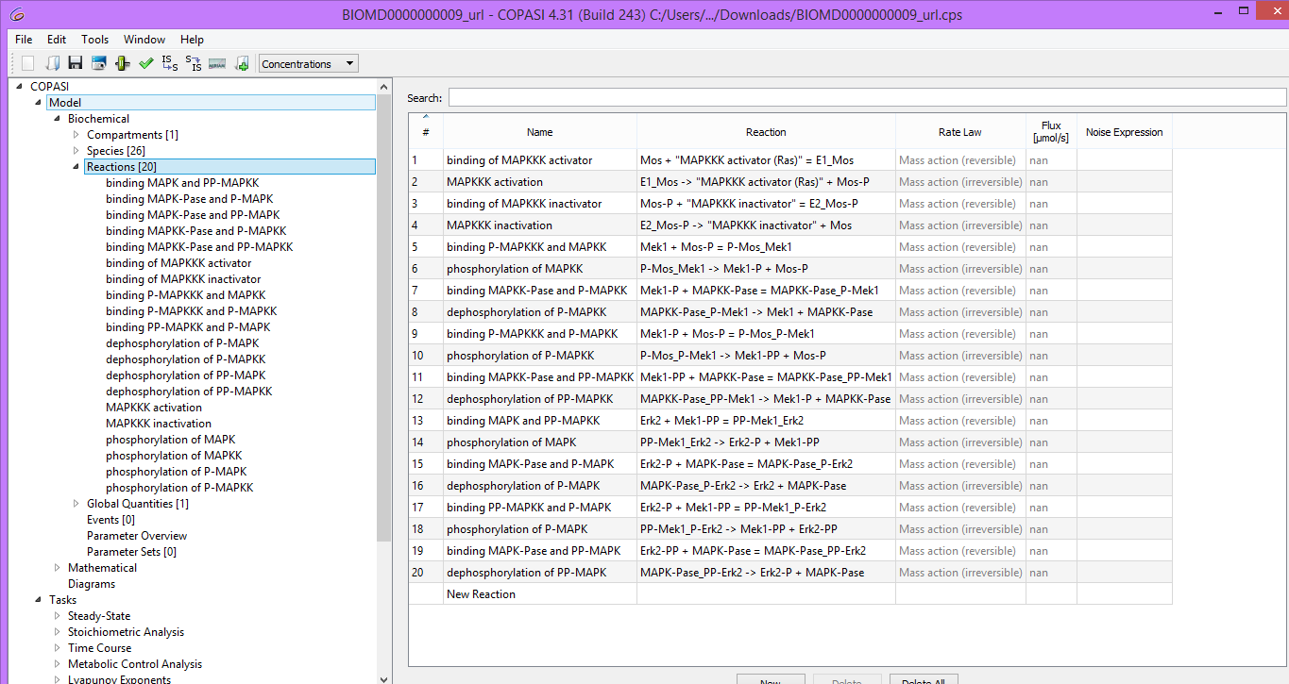

5. A Time Course (from Tasks dropdown menu on the left hand side select time course) is prepared whose duration = 100 seconds, interval size = 0.1 seconds, method = Deterministic (LSODA).

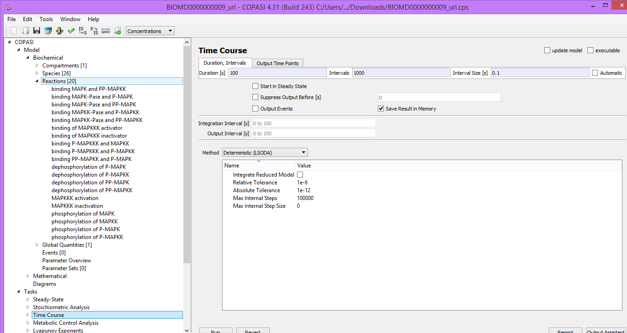

6. Using the Output Assistant a time course of “concentrations, volumes and global quantities “is created and then run.

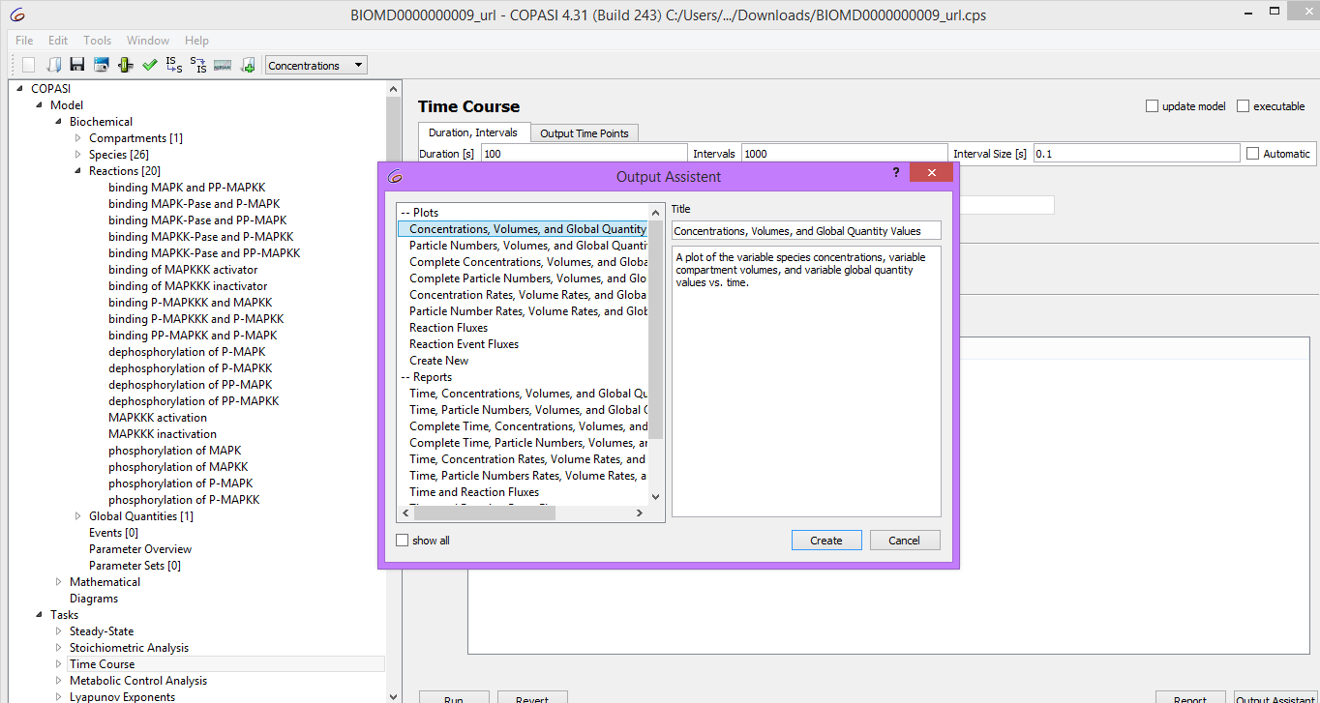

7. All of the curves except for the normalized active forms of MAPK,

(“K_PP_norm”), MAPKK (“KK_PP_norm”) and MAPKKK (“KKK_P_norm”) are hidden.

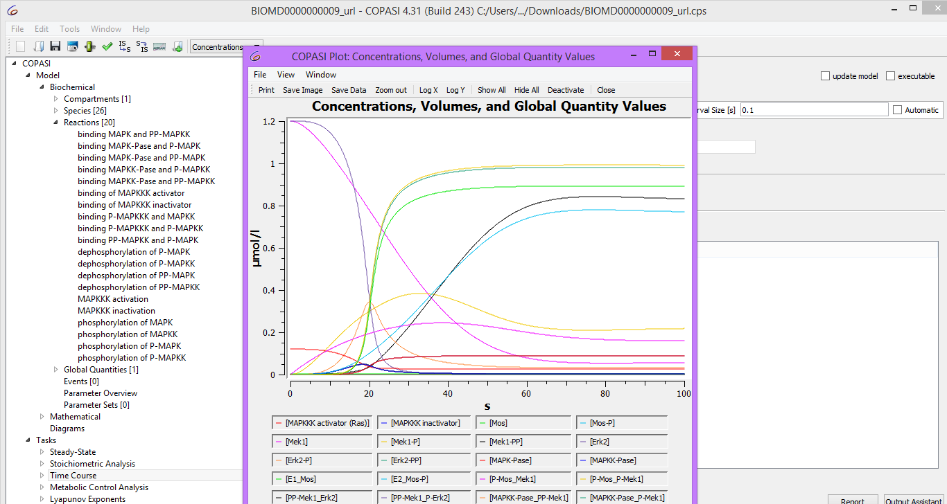

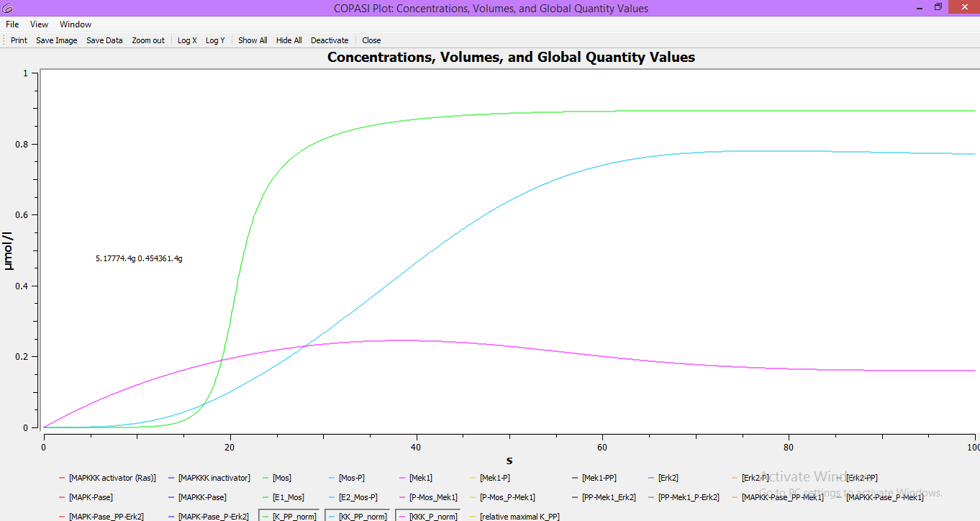

8. Save your model for further analysis.

**1b. Creating a dose-response curve – sensitivity to signal:**

* The **dose–response relationship**, or **exposure–response relationship**, describes the magnitude of the [response](https://en.wikipedia.org/wiki/Stimulus%E2%80%93response_model) of an [organism](https://en.wikipedia.org/wiki/Organism), as a [function](https://en.wikipedia.org/wiki/Function_(mathematics)) of exposure (or [doses](https://en.wikipedia.org/wiki/Dose_(biochemistry))) to a [stimulus](https://en.wikipedia.org/wiki/Stimulus_(physiology)) or [stressor](https://en.wikipedia.org/wiki/Stressor) (usually a [chemical](https://en.wikipedia.org/wiki/Chemical)) after a certain exposure time.
* Dose–response relationships can be described by **dose–response curves**.
* Dose response studies help us understand any change caused by varying a dosage on the dynamics of the system.
* These are used for instance to determine the efficient, “safe” and “hazardous” dosages of drugs and optimize any perturbation protocol.
* The numerical procedure is called parameter scan, or parameter sweep. As the name indicates, they can also be used to study the effect of varying parameters in a model and study the sensitivity of a system towards this parameter

Here we will study the stimulus response curves for three components of the MAPK cascade, the

input stimulus being the MAPKKK_activator (INPUT (E1) on the map above, for instance Ras). We will compute the steady state of all concentrations (when their values do not vary anymore) for increasing values of the MAPKKK_activator.

**PROCEDURE:**

1. Select Parameter Scan (from Tasks dropdown menu) and change the Task type to “Steady State”.



2. Set new scan item to scan and click create.

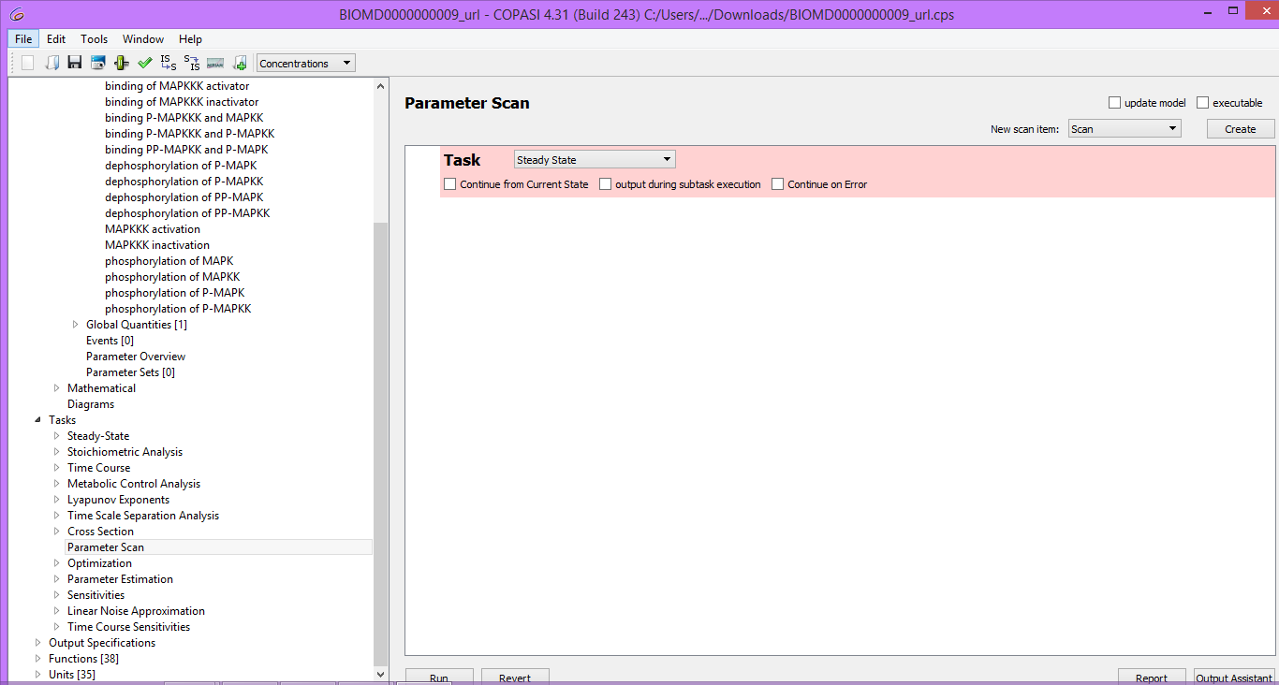

3. Select the parameter to be scanned as initial concentration of the [MAPKKK activator](t=0)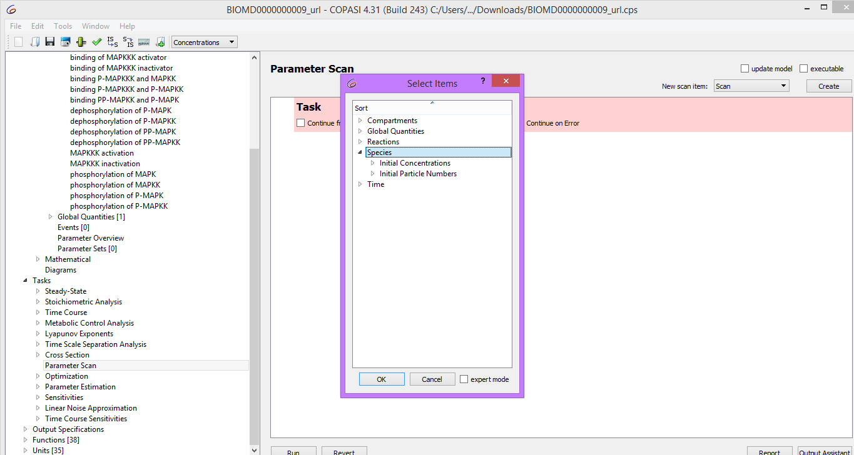

4. In the scan item you have just created set: the parameters of intervals = 100, minutes =1e-6, max = 0.1 and select logarithmic.

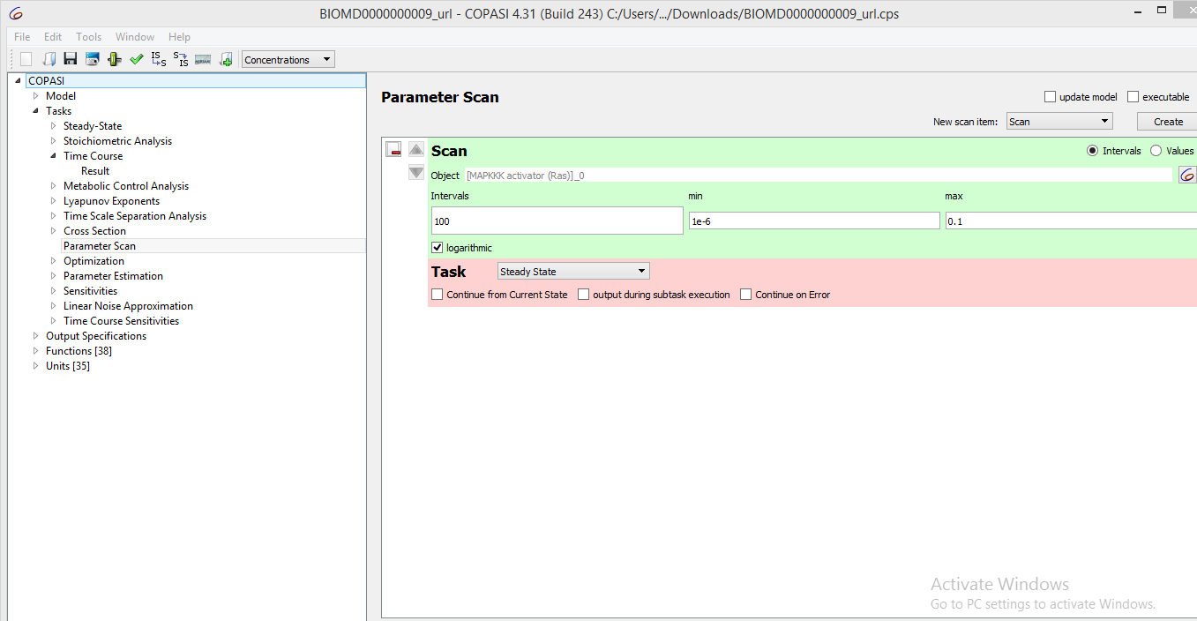

5. Use of the output assistant to create a “scan of concentrations, volumes and global quantity values” plot. Use a log scale for the x axis (MAPKKK_activator). Run the scan to get the dose response curves.

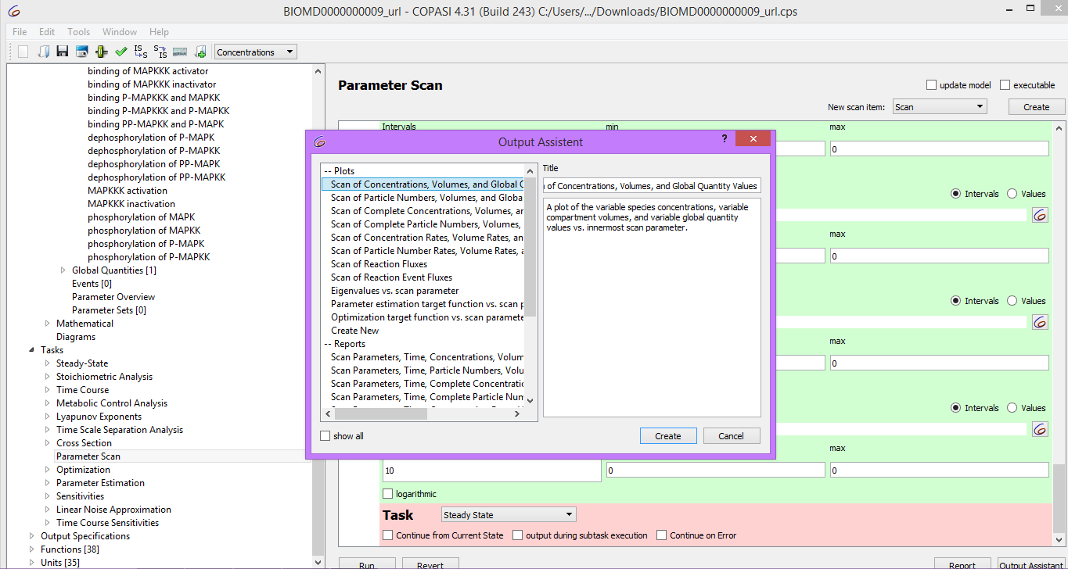

6. Hide all the curves except for the normalized active form of the MAPK

(“K_PP_norm”).MAPKK (“KK_PP_norm”) and MAPKKK (“KKK_P_norm”).

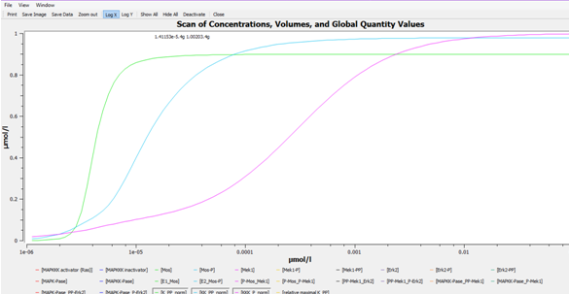

7. Save your model

Inference from the time-course and the dose-response curve:

* The simple time course simulation shows the expected temporal sequence of kinase activation, from MAPKKK to the final effector MAPK.
* It shows that the activity of MAPK reaches its maximal level before MAPKKK and also hints at the increase in sensitivity along the levels of the cascade.
* The dose-response plot directly shows the strong increase in sensitivity along the levels of the cascade with the MAPK curve predicted to be the steepest.
* This plot also teaches us two different very important characteristic of the mapkinase cascade.
* The half activation of the ERK happens at lower RAS concentration (4.4muM) than that of MEK (13muM) or RAF (260nuM).
* Thus the slope of the curve for ERK is steeper than for MEK itself steeper than for RAF.
* Such a cascade of covalent modifications provided a new mechanism to generate ultra sensitivity, in addition to the allosteric regulation of multisite, multimeric proteins, in addition this is a brilliant demonstration of the emergent properties of biological systems, and the absolute need to study the behavior of the whole system.

**INSILICO SYSTEMS BIOLOGY PRACTICALS**

**EXPERIMENT -18**

**Aim:** Building Biological Networks using Cytoscape and explore GeneMania App.

**Theory:**

* Cytoscape is an open source software platform for visualizing molecular interaction networks and biological pathways and integrating these networks with annotations, gene expression profiles and other state data. Although Cytoscape was originally designed for biological research, now it is a general platform for complex network analysis and visualization.
* Cytoscape core distribution provides a basic set of features for data integration, analysis, and visualization. Additional features are available as Apps (formerly called Plugins). Apps are available for network and molecular profiling analyses, new layouts, additional file format support, scripting, and connection with databases. For example: GeneMania, Bingo, String, cyCHART, Network Merge, ClueGO, CluePedia, MCODE.
* Cytoscape supports many use cases in molecular and systems biology, genomics, and proteomics:
* Load molecular and genetic [interaction data sets](http://www.imexconsortium.org/) in [many standards formats](http://manual.cytoscape.org/en/stable/Supported_Network_File_Formats.html)
* Project and integrate global datasets and functional annotations
* Establish powerful visual mappings across these data
* Perform advanced analysis and modeling using [Cytoscape Apps](http://apps.cytoscape.org/)
* Visualize and analyze human-curated pathway datasets such as [WikiPathways](http://www.wikipathways.org/index.php/WikiPathways), [Reactome](http://www.reactome.org/), and [KEGG](http://www.genome.jp/kegg/pathway.html).

**Procedure:**

1. Download Cytoscape from <https://cytoscape.org/> and Install Cytoscape in your system.

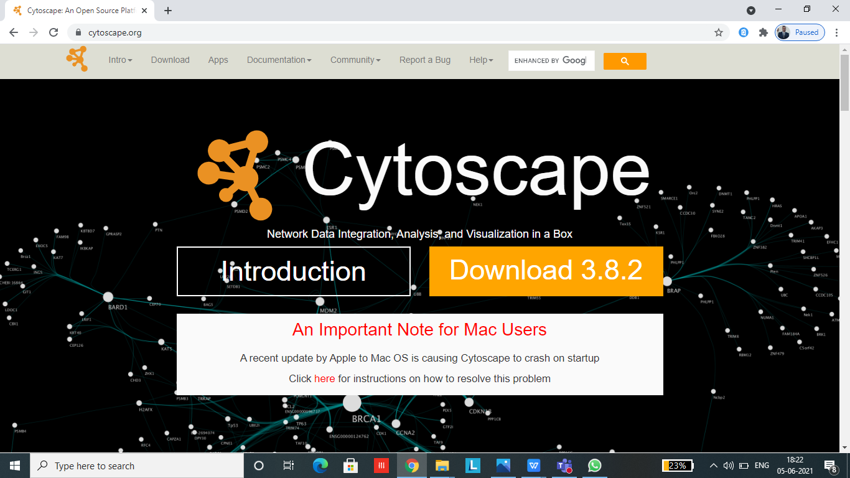

2. Open Cytoscape and the home page will look like this:

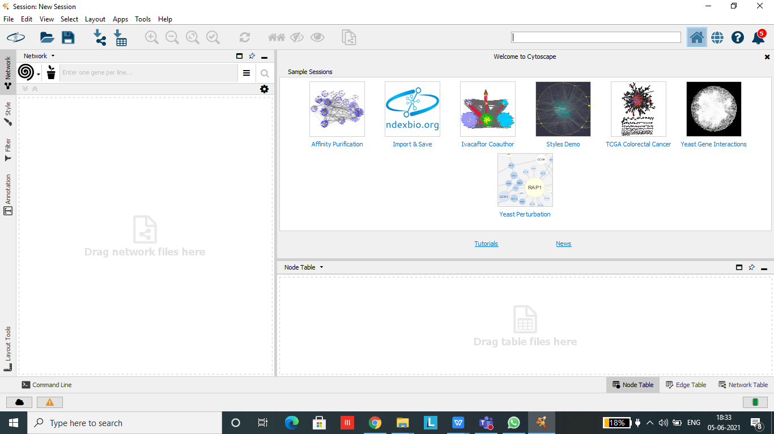

3. Go to Files >> New >> Network >> Empty Network. On clicking Empty, a box named “Create New Network” will appear, enter the network name and click OK.

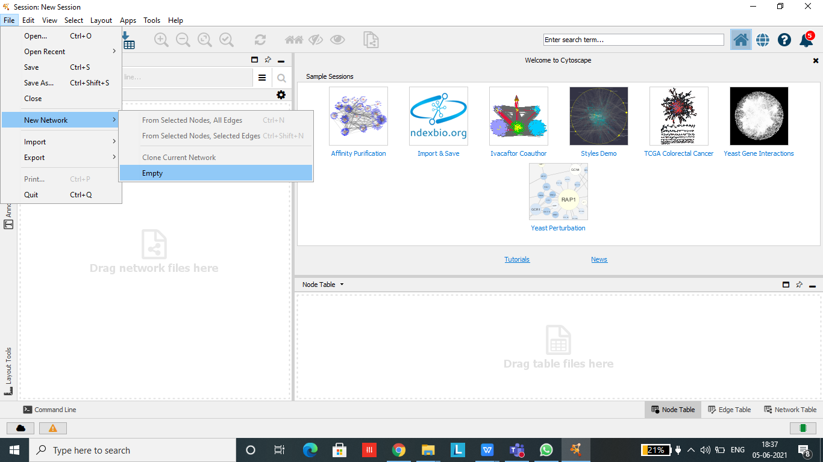

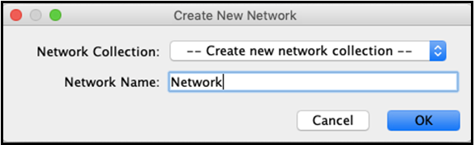

4. New network window which is white in colour will open now where we can make a network.

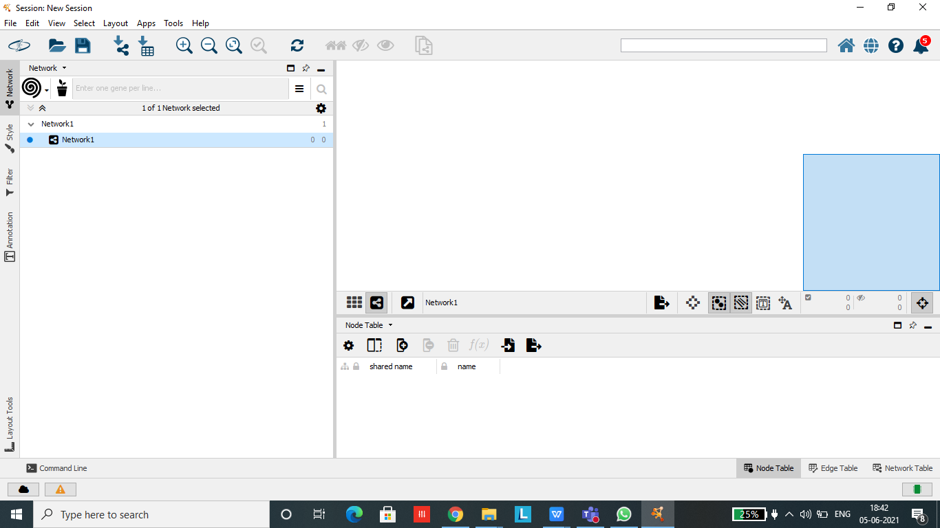

1. Right click on the empty window to add nodes and edges and build network.

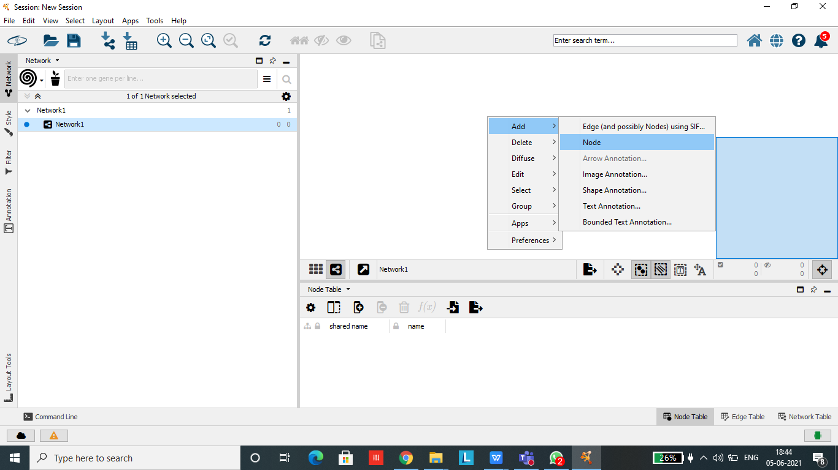

1. After building the network we need to annotate the network. For this Go to Annotation >> Select the annotation you want to add >> Click on the node or edge that you want to annotate.

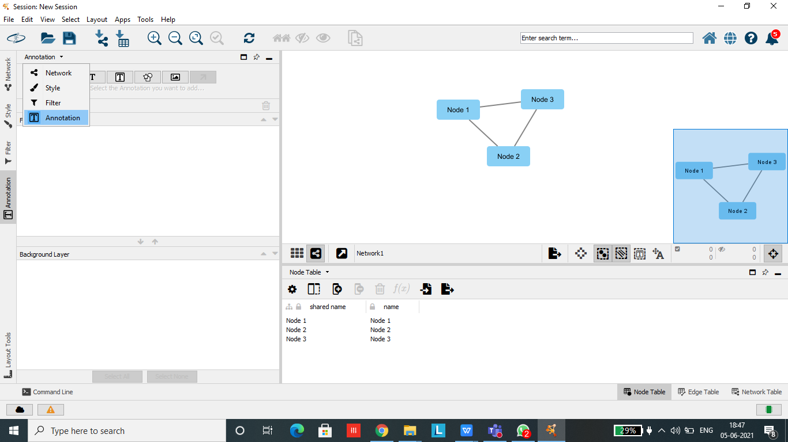

* **GeneMania Exercise : Network Construction and exploration using GeneMania App.**

**Step 1**: Go to Apps >> Apps Manager >> Download GeneMania app for your Cytoscape.

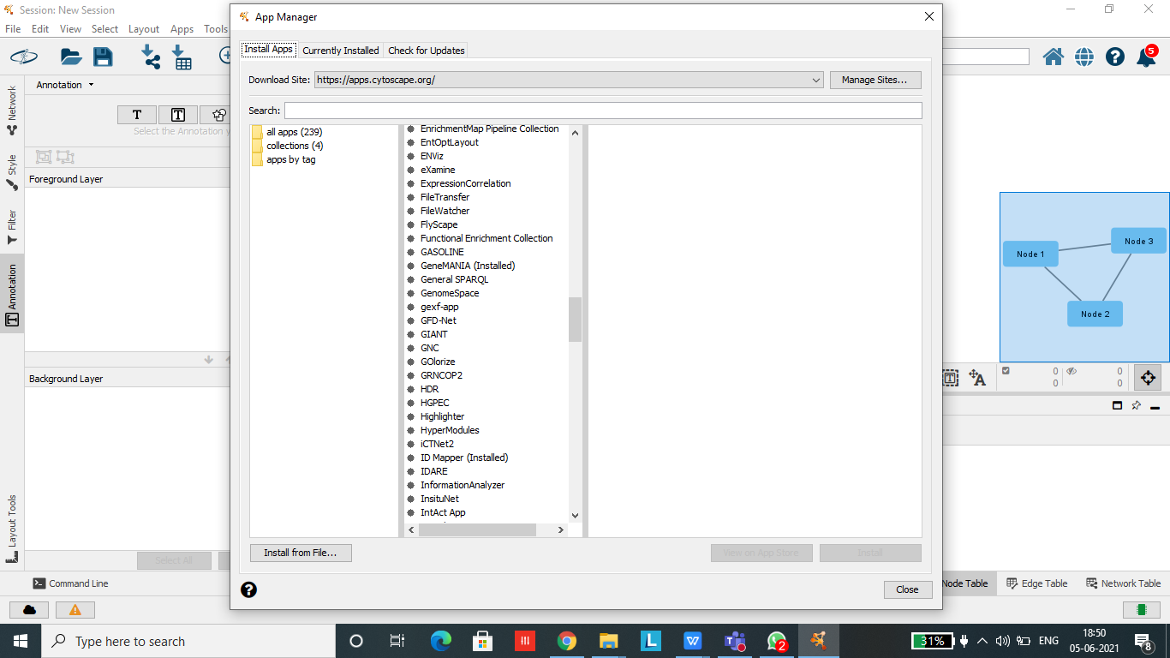

**Step 2** : Select GeneMania from the dropdown menu on the left hand side and *Homosapiens* from the dropdown menu adjacent to it.

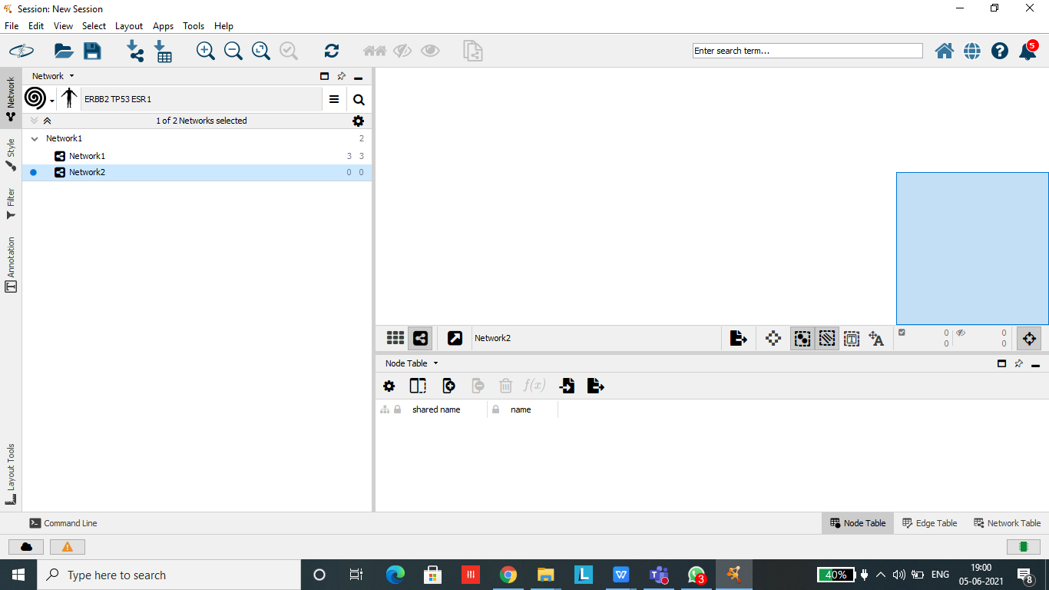

**Step 3**: Copy and paste the genes in the provided space and click on more options to set the desired values for building the network and click search.

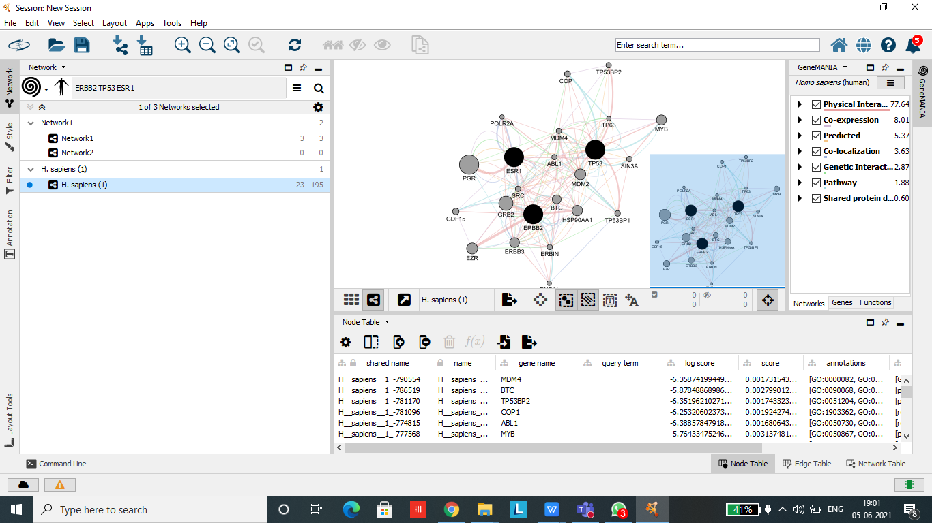

Page Break

**Step 5** : The constructed multiple network should appear. Manually move the nodes of the network until you are happy with the layout.

**Step 6** : Save the image of the network.

**Step 7** : Save the interaction information so that we could import the network into other programs, such as Cytoscape, for manipulation and analysis.

**INSILICO SYSTEMS BIOLOGY PRACTICALS**

**EXPERIMENT -19**

**AIM**- To explore David Database to interpret the biological mechanisms associated with large gene lists.

**Theory-**

DAVID bioinformatics resources is an integrated biological knowledgebase and analytical tool aimed at extracting biological meaning from large gene/protein lists generated from a variety of High throughput genomic experiments. The Database for Annotation, Visualization and Integrated Discovery (DAVID ) v6.8 comprises a full Knowledgebase update to the sixth version of our original web-accessible programs. DAVID now provides a comprehensive set of functional annotation tools for investigators to understand biological meaning behind large list of genes. The expanded DAVID Knowledgebase now integrates almost all major and well-known public bioinformatics resources centralized by the DAVID Gene Concept, a single-linkage method to agglomerate tens of millions of diverse gene/protein identifiers and annotation terms from a variety of public bioinformatics databases. For any uploaded gene list, the DAVID Resources now provides not only the typical gene-term enrichment analysis, but also new tools and functions that allow users to condense large gene lists into gene functional groups, convert between gene/protein identifiers, visualize many-genes-to-many-terms relationships, cluster redundant and heterogeneous terms into groups, search for interesting and related genes or terms, dynamically view genes from their lists on bio-pathways and more. For any given gene list, DAVID tools are able to:

* Identify enriched biological themes, particularly GO terms
* Discover enriched functional-related gene groups
* Cluster redundant annotation terms
* Visualize genes on BioCarta & KEGG pathway maps
* Display related many-genes-to-many-terms on 2-D view.
* Search for other functionally related genes not in the list
* List interacting proteins
* Explore gene names in batch
* Link gene-disease associations
* Highlight protein functional domains and motifs
* Redirect to related literatures
* Convert gene identifiers from one type to another.

And more

**PROTOCOL-**

1. Open the home page for the DAVID resources site using <http://david.abcc.ncifcrf.gov>

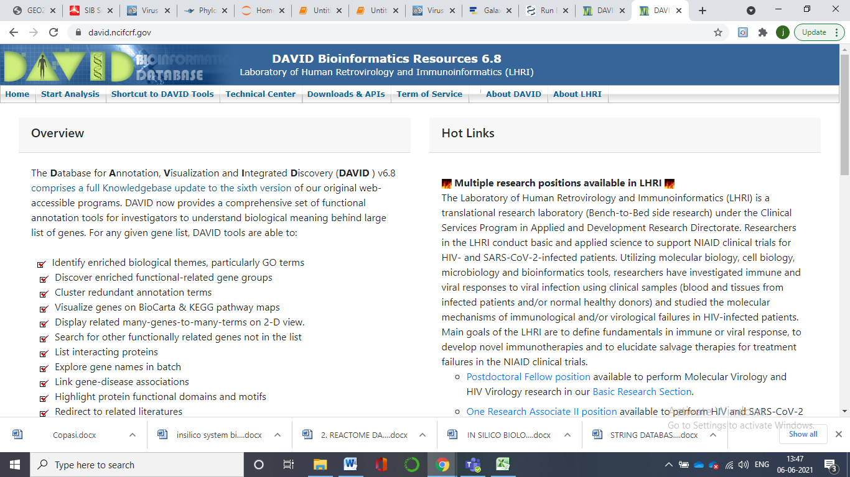

2. Go to Functional Annotation

3. Paste gene sequence in the box on the left side or upload a gene sequence from the device folder. Select the type of sequence submitted and type of list. Further submit the sequence. (NOTE : One gene could have several different identifiers within one or more database(s). Similarly, the biological terms associated with different gene identifiers for the same gene could be collected in different levels across different databases. Due to these issues, most high-throughput annotation tools rely on one, or at most a few, resource(s), which limits the analytic comprehensiveness and the level of throughput. The DAVID Knowledgebase is now built around the ‘DAVID Gene Concept’, a single linkage method to agglomerate

tens of millions of gene/protein identifiers from a variety of public genomic resources including NCBI, PIR and UniProt.) Over 22 types of gene identifiers integrated by the DAVID Gene Concept within the DAVID Knowledgebase.

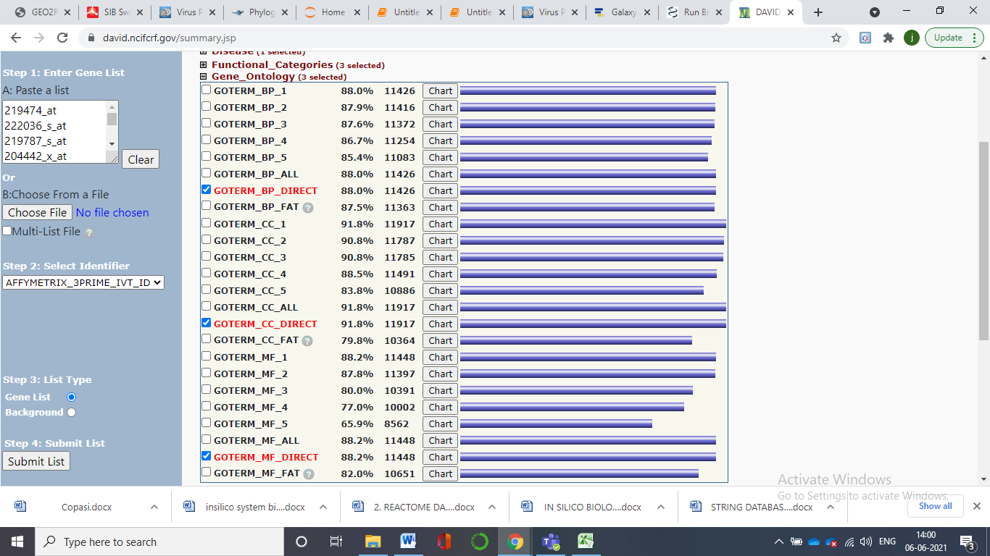

4. Results are displayed consisting of all the categorizations.. Now chose the organism you need to work with. This function uses a novel algorithm to measure relationships among the annotation terms based on the degrees of their co-association genes to group the similar, redundant and heterogeneous annotation contents from the same or different resources into annotation groups. This reduces the burden of associating similar redundant terms and makes the biological interpretation more focused in a group level. (The gene names are hot links to pages with information about the genes. The RG links will display in a new tab, a list of other genes within the submitted list that are related to the gene you clicked on. These relationships are based on a statistical measure of functional similarity. )

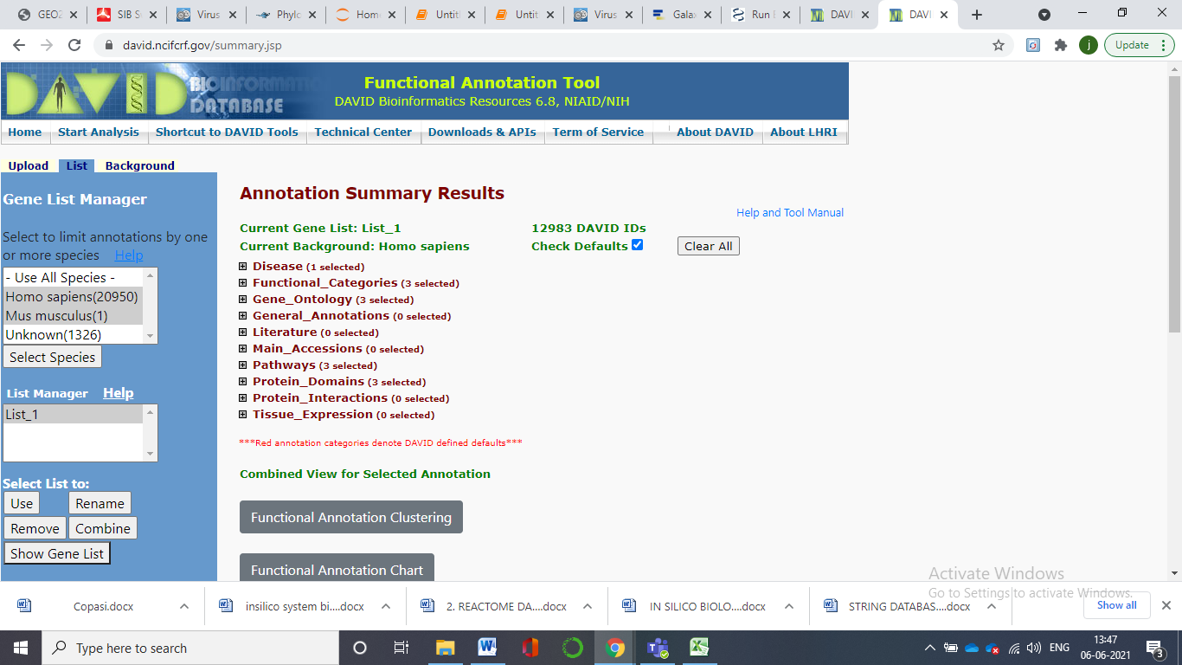

5. Click on the Plus symbol and expand the categorization results.

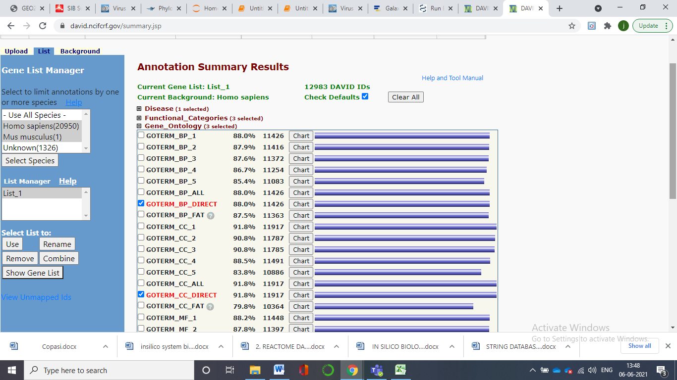

Here we can see that in the Genetic Association Database (GAD), there are 88 % (11426 of them) of our chainlist that overlap or map with genetic association database.

6. Click on the blue bar. It will take you to the 11426 disease database.

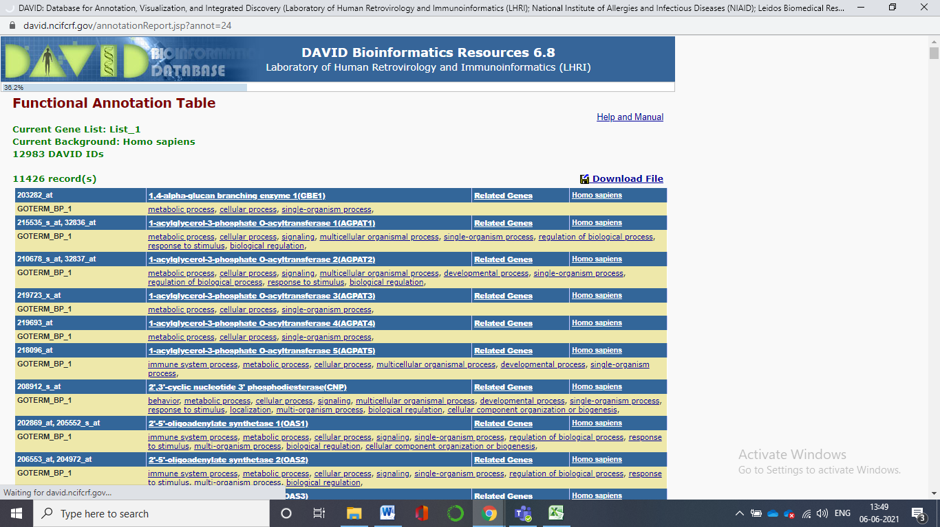

7. Clicking on the chart button given us the enrichment analysis results.

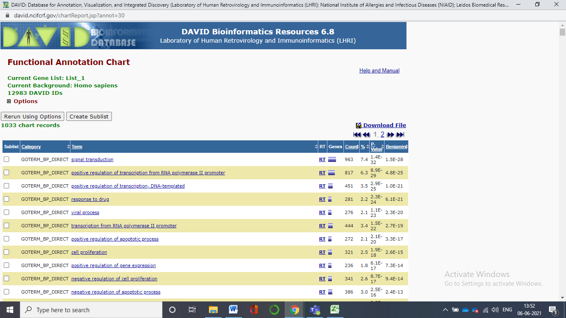

8. The plus symbol in the options can help us edit the requirements. We can adjust the threshold value, fold enrichment, number of records etc. The new DAVID Gene Name Batch Viewer is designed to simply list the gene names for all given genes. In addition, hyperlinks are provided on each gene entry, allowing users to explore in depth other functional information around the gene. Thus, this tool provides users with a first glance and initial ideas about their interesting genes before proceeding to analysis by other more comprehensive analytic tool. Moreover, hyperlinks, labeled as ‘RT’, are provided for each

gene in order to search other functionally related genes in user's gene list or the entire genome.

(instead of a long list of single terms, you see clusters of terms that are related to each other. The clusters are shown in order of decreasing enrichment scores. If you click on the red G button located on the blue bar at the top of each cluster, you should get a list of the genes in that cluster that are annotated with one or more of the terms.)

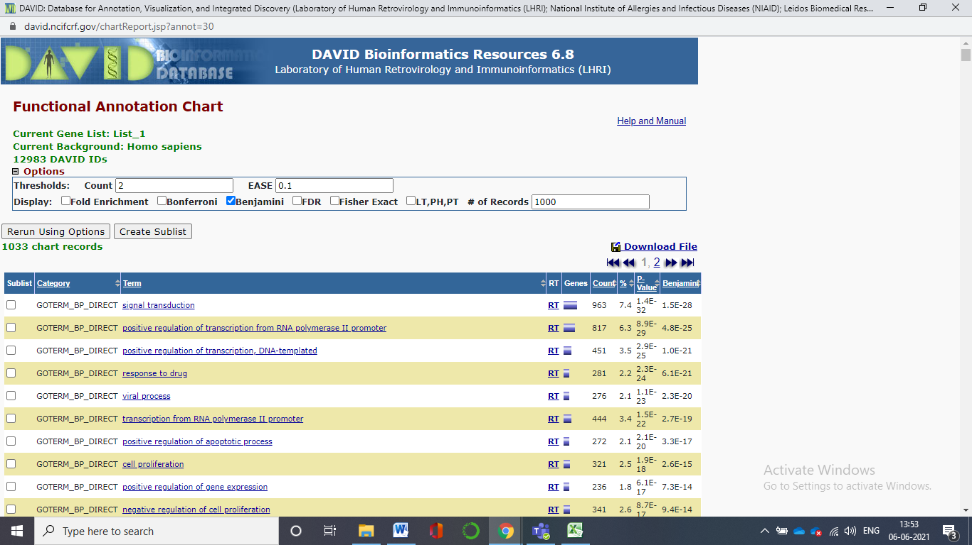

9. In the first mentioned Biological Process is signal transduction -The cellular process in which a signal is conveyed to trigger a change in the activity or state of a cell. Signal transduction begins with reception of a signal (e.g. a ligand binding to a receptor or receptor activation by a stimulus such as light), or for signal transduction in the absence of ligand, signal-withdrawal or the activity of a constitutively active receptor. Signal transduction ends with regulation of a downstream cellular process, e.g. regulation of transcription or regulation of a metabolic process. Signal transduction covers signalling from receptors located on the surface of the cell and signalling via molecules located within the cell. For signalling between cells, signal transduction is restricted to events at and within the receiving cell. By clicking on the list another tab. The download option in that file help us to download the results.

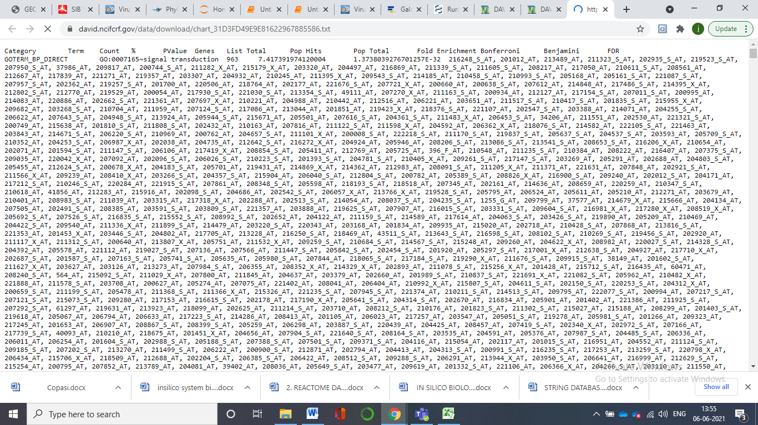

**INSILICO SYSTEMS BIOLOGY PRACTICALS**

**EXPERIMENT- 20**

**AIM-** To explore Panther Database

**Theory-** The PANTHER (**P**rotein **AN**alysis **TH**rough **E**volutionary **R**elationships) Classification System was designed to classify proteins (and their genes) in order to facilitate high-throughput analysis. Proteins have been classified according to:

* Family and subfamily: families are groups of evolutionarily related proteins;

subfamilies are related proteins that also have the same function

* Molecular function: the function of the protein by itself or with directly interacting proteins at a biochemical level, e.g. a protein kinase
* Biological process: the function of the protein in the context of a larger network of proteins that interact to accomplish a process at the level of the cell or organism, e.g. mitosis.
* Pathway: similar to biological process, but a pathway also explicitly specifies the relationships between the interacting molecules.

The PANTHER Classifications are the result of human curation as well as

sophisticated bioinformatics algorithms. PANTHER is a comprehensive database of evolutionary and functional information about protein-coding genes. Protein sequences (one representative sequence per gene) from 104 complete genomes (PANTHER uses the UniProt Reference Proteomes data set ) are organized into families of homologous genes. For each family, a phylogenetic tree is constructed, representing the evolutionary relationships between all genes in the family, and the processes by which these genes were first copied and then diverged from each other: speciation, gene duplication and horizontal transfer.

**Protocol-**

1. Open Panther Database

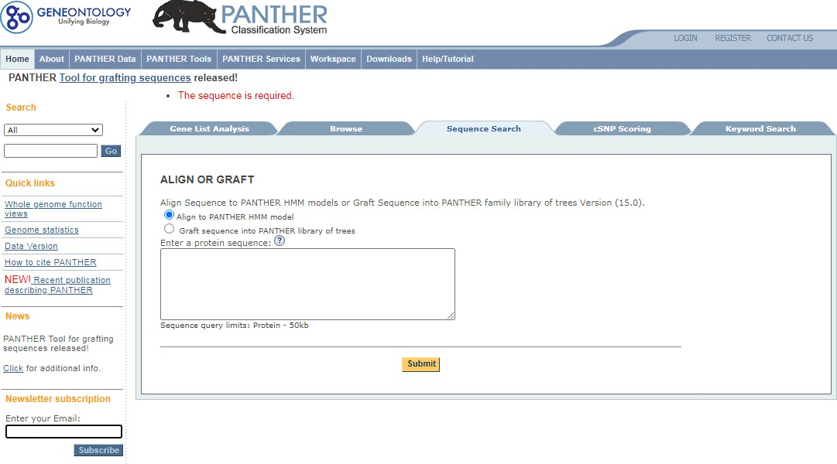

1. 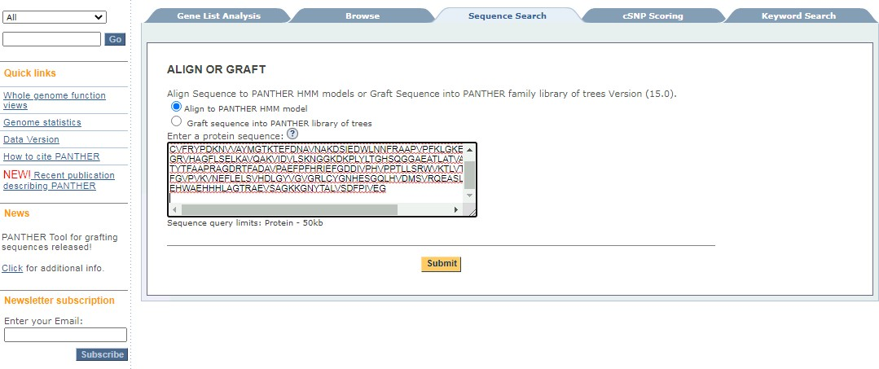Enter a Protein Sequence and press submit button.
2. 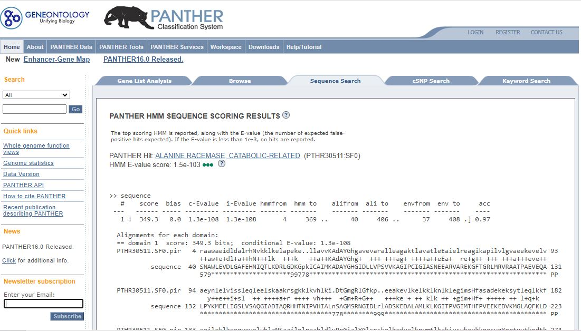After submitting, it takes to the window displaying Sequence search results. In this case, the results show that they belong to the Alanine Racemase  family.

4.The hyperlinked protein’s super family takes to the next window showing the information regarding the superfamily and Genes assigned to the subfamily.

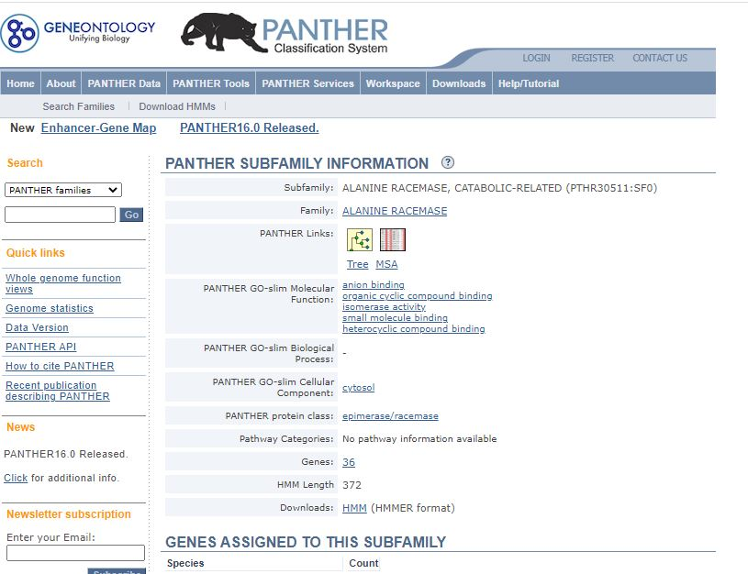

1. There are 2 Panther Links. One showing the Phylogenetic tree and the second is the multiple sequence alignment. The Panther Tree viewer looks like-

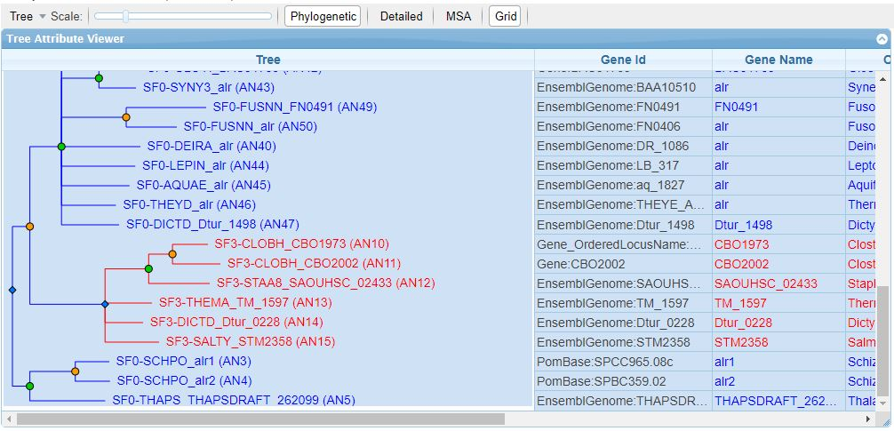

PANTHER version 15.0 contains 15702 protein families, each with a phylogenetic tree relating modern-day genes in 142 organisms. Phylogenetic trees also infer the evolutionary events that occurred, namely speciation (green nodes) and gene duplication events (orange nodes). Horizontal transfer events are not inferred in this version of PANTHER, but will appear in future versions. Expert biologists have divided each family into subfamilies, which are generally orthologous groups but may also contain recently duplicated paralogs. Each family and subfamily is also represented as a hidden Markov model (HMM), which can be used to classify new sequences to an existing subfamily.

1. PANTHER multiple sequence alignments (MSAs) are the basis for the PANTHER distance trees, and therefore of the family/subfamily classification. You can view them in two modes:

**Full MSA**: Includes all (publicly available) sequences in the family that are related closely enough to produce an informative multiple alignment (i.e. the resulting trees and HMMs are useful for function prediction at both a family and subfamily level).

**Partial MSA**: Shows the alignment for only the currently selected subfamilies. In the MSA viewer, you can:

* Change the selection of subfamilies shown by clicking on "Subfamily Selection" just as in the Tree Viewer.
  + Focus on only a part of the sequence alignment ("range").
  + Change the font size of the alignment.
  + Jump to the start or end positions of the HMM alignment (by clicking on the links after the HMM length).

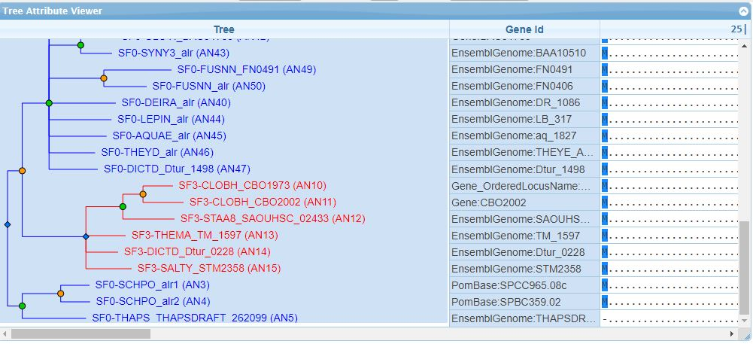

1. The gene statistics

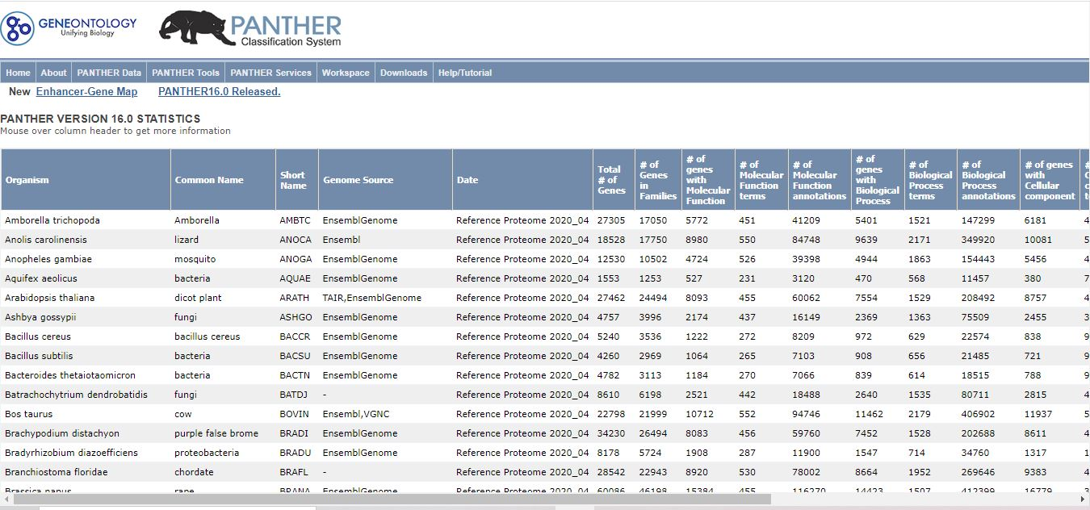

**INSILICO SYSTEMS BIOLOGY PRACTICALS**

**EXPERIMENT-21**



Sandra Orchard/Pablo Porras (V6 01/07/13)

A tour of the IntAct Portal

[*http://www.ebi.ac.uk/intact*](http://www.ebi.ac.uk/intact)

*With this tutorial you will learn how to:*

* *Perform a simple search in IntAct and graphically visualise it*
* *Extend the search to produce a more extensive network*
* *Look at the details of an individual interaction*
* *Perform more complex, directed searches*

*The IntAct curation policy is to provide the user with all the experimental detail described in the originating paper, with all entries being fully IMEx- and MIMIx-compliant and providing extra levels of detail beyond these minimum requirements. To do so, IntAct makes extensive use of a number of controlled vocabularies, primarily PSI-MI to describe the technical details of the experiment, binding sites, protein tags and mutations and Gene Ontology to describe the subcellular location an interaction may be shown to occur in or the function of an enzyme in an enzyme/substrate assay. Interacting molecules are systematically mapped to stable identifiers from public databases such as UniProtKB for proteins, ChEBI for small molecules, Ensembl for genes and the DDBJ/EMBL/GenBank nucleotide databases for nucleic acids. Features within a molecule, such as a binding site on a protein, are mapped to the sequence/structure given in the under-lying database and remapped should a new version of the underlying sequence be released. Binding sites are also cross-referenced to the InterPro database, whenever possible.*

A simple search and visualisation of data

Using the Quick Search

In this search panel you are free to type anything that might relate to interactions, whether it is properties of their interactor (gene name, Accession Numbers, GO term…) or more specific to the interaction such as publication ID, authors, experimental detection method… Usually users will type an accession number or gene name.

In this exercise you will perform a very simple search and look at your results in the IntAct viewer. You may perform the exercise below or alternatively, you may try a protein you are interested in through your own work. However, you may find there is little or no data for your protein in the database, particularly if it originates from a non-model organism which are much less well studied.

This work is licensed under the Creative Commons Attribution-Share Alike 3.0 License. To view a copy of this license, visit <http://creativecommons.org/licenses/by-sa/3.0/> or send a letter to Creative Commons, 543 Howard Street, 5th Floor, San Francisco, California, 94105, USA.



1

 Type ‘CHK2’ into the IntAct Quick search and hit ‘Search’

**Question 1** How many binary interactions does this find – and how many is this reduced by when you ‘filter’ out the spoke expanded co-complex data?

 Graphically view the data within IntAct

 Open the ‘List’ tab and select all proteins (use the check box at the top of the table) and use ‘search for interactions’ to perform a second round of search.

 **Question 2** How many interactors can you now find?

 Clear the search and perform a second search on CHK2_HUMAN

 **Question 3** How many interactors do you now find?

 Go to the detailed view of the interaction of CHK2 with BRCA1 (EBI-1263190)

 **Question 4**: Which other proteins are co-complexed with this molecule?

 **Question 5**: What protein feature was observed for CHK2 (Open red F) – and on which amino acid is it seen?

**Refining your search**

1. **Using the Advanced Search**

Clicking on the “Fields” button to the right of the Quick Search box will open up the Advanced Search, allowing you to specify one or more fields you wish to search in, and building the query for you as you progress.

Let’s do a blank search defined only by the field you want to search with. In this example, we will start by looking for all the interaction involving human proteins that can be found in IntAct.

 Clear your search before you start this part of the tutorial.

Click on ‘Fields’ and select ‘Organism’ from the pull-down menu – type in ‘Human’ as your organism.

 Further refine the search by adding “Detection method” as “Experimental” – you should see a slight drop in interaction number on the Interaction tab as some inferred data is filtered out. Finally, actively filter out all the two hybrid data by checking the NOT box and selecting “Detection method” as “two hybrid” – you should loose about 10,000 interactions as all the two hybrid (and child thereof) data is removed.

2

If you want to construct more complex queries we recommend you take a look at the Molecular Interaction Query Language, accessible from the quick search panel. This will allow you to write more complex queries, for example:

Clear your search before you start this part of the tutorial.

Try the query: taxidA:9606

This will select all interactions where at least one of the participants is of human (NCBI Taxonomy ID = 9606) origin. Make a note of the number. ‘Clear’ the current search.

 Now try the query taxidA:9606 AND taxidB:9606

This query selects all interaction where BOTH interactors are of human origin. You will see the numbers differ significantly. This is due to mixed species interactions. Some of these are biologically significant (e.g. human – HIV proteins) but others are caused by a the experimental systems constructed by bench scientists (e.g. a Flag-tagged human protein expressed in a mouse cell line and used to co-immunoprecipitate mouse proteins).

1. **Using the Ontology Search**

Open the Search Tab. This panel is specialised to give you an easy access to ontology search. So far you can search on 4 ontologies:

Gene Ontology InterPro

PSI-MI ChEBI

Whenever you start typing a query in this search panel, the system will search as you type and propose a list of matching controlled vocabulary terms. You can then select one of them and select matching interactions.

 Clear your search before you start this part of the tutorial.  Type: ‘mitosis’ in the Ontology Search box.

You will be presented with a few choices, please note that each term is followed by the count of matching interactions in the IntAct database.

 Select the parent term ‘mitosis’ (GO:0007067) using the keyboard cursor keys, complete the search and you will be taken to the interaction tab. This now gives you ALL the interactions for proteins in IntAct which GO have annotated as being involved in the process of mitotis. Add the term ‘AND species:human’ to limit this to interactions in which one of the interactors is of human origin.

3

1. **Extending your search via PSICQUIC and IMEx**

At the same time that you perform a query in IntAct, we simultaneously also perform the same query across all the databases hosting a PSICQUIC server and also across the consistently curated, non-redundant set of interactions available via the IMEx website.

 Clear your search before you start this part of the tutorial.

 Go to the IntAct home page and perform a quick search on ‘brca2’. You will see a response similar to that listed below.



Clicking on the hyperlink will allow you to access additional data. Remember, collectively the PSICQUIC databases contain highly redundant data and also predicted and inferred data as well as experimentally curated. The IMEx set will give you additional data curated to the same high standards as is IntAct, and this dataset is non-redundant with regard to experimental evidence.

4

Further Reading

* The UniProt Consortium “Reorganizing the protein space at the Universal Protein Resource (UniProt).” Nucleic Acids Res. (2012) 40:71-75
* Leinonen R, Nardone F, Zhu W, Apweiler R “UniSave: the UniProtKB sequence/annotation version database.” Bioinformatics (2006) 22:1284- 1285
* Suzek BE, Huang H, McGarvey P, Mazumder R, Wu CH “UniRef: comprehensive and non-redundant UniProt reference clusters.” Bioinformatics (2007) 23:1282-8
* Mulder NJ et al “New developments in the InterPro database.” Nucleic Acids Res. (2007) 35:D224-8
* Kerrien S et al “The IntAct molecular interaction database in 2012.” Nucleic Acids Res. (2012)40:D841-846

5

IntAct

Answer 1: 43 – reducing to 35

Answer 2: 514 (494 proteins, 6 compounds, 5 nucleic acids and 9 genes) Answer 3: 40

Answer 4: RAD50, TP53BP1 and GINS2

Answer 5: Phospho-threonine – residue 68

6